

Data Warehousing & Business Intelligent

(IT)

3rd Year, 1st Semester

**Assignment 1**

Submitted to

Sri Lanka Institute of Information Technology

Bachelor of Science Special Honors Degree in Data Science

IT19167510Bandara J.M.S.A

Weekday Batch

# Step 1-*Description Of The Data Set*

## ➢ *San Francisco Building permits - kaggle.com*

I selected the San Francisco Building Permits as the data set. It consists of a large CSV file with a small xlsx file. Furthermore , I have partitioned the large CSV file into small sub CSV files. The sub CSV files consists of new IDs.

A building permit is an official approval document issued by a governmental agency that allows San Francisco’s contractor to proceed with a construction or remodeling project on one's property. San Francisco has its own office related to buildings, that can do multiple functions like issuing permits, inspecting buildings to enforce safety measures, modifying rules to accommodate needs of the growing population etc.

***Reason for importance :- In the recent past, main discrepancy in demand and supply in real estate industry is due to delays in issuing building permits***

Data set has these files named :

* Building_Permits.csv
* DataDictionaryBuildingPermit.xlsx

## ➢ *ER Diagram*

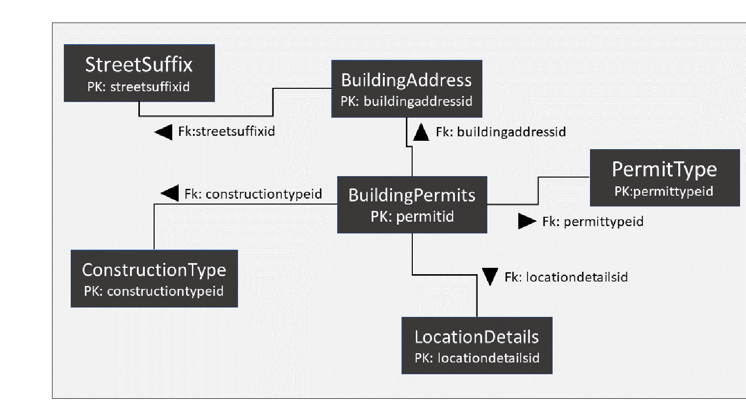

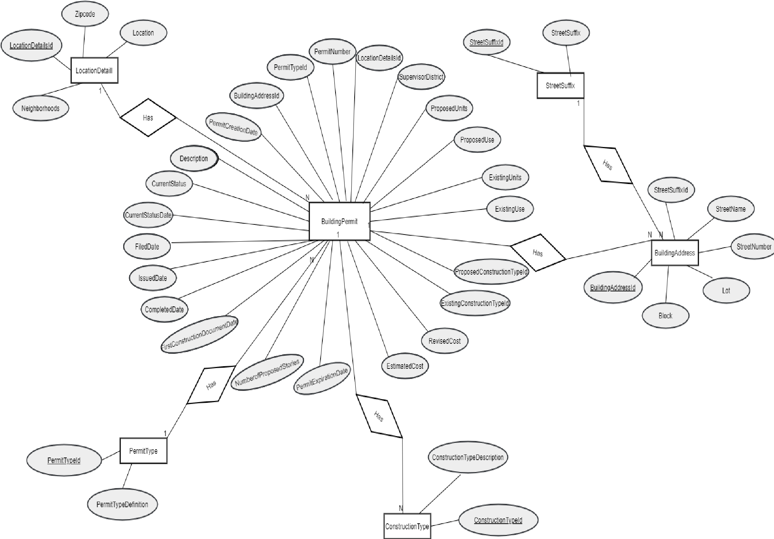

# Step 2 – *Preparation of data sources*

This implement data warehouse used data set view, it is Building Permits data set. It partitioned in to separate Source files to implement data warehouse, suchas *Constructiontype.csv , PermitType.csv,LocationDetailsId.txt,BuildingPermits.txt,BuildingAddress.sql and streetSuffix.sql*

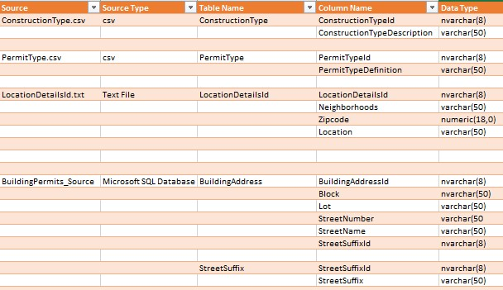

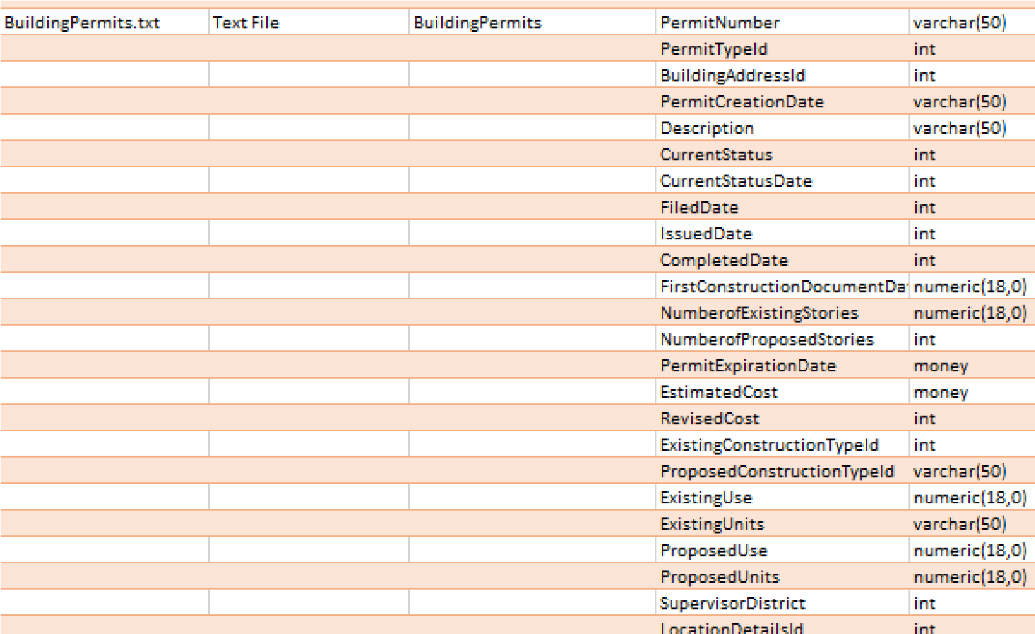

# Step 3 - *Solution architecture*

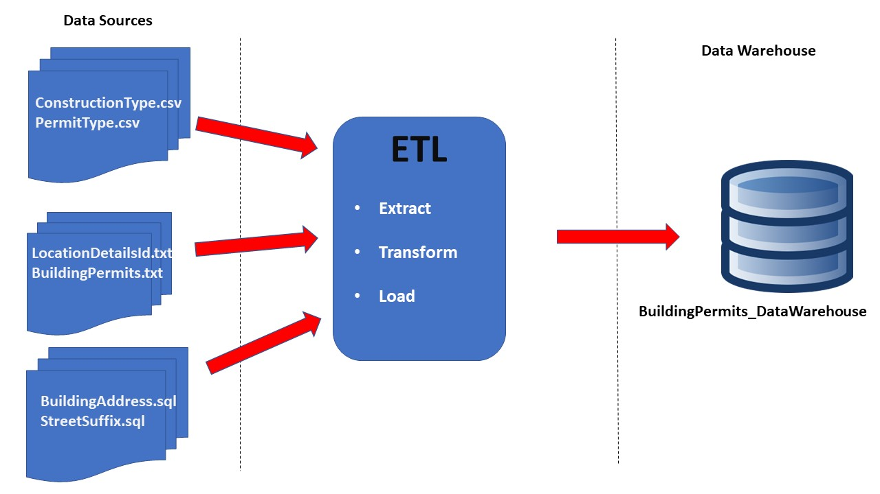

The datawarehouse is the core of the BI system.We design a datawarehouse for the purpose of the analysis and reporting.

# Step 4: Data warehouse design & development

This diagram show you how the fact table and dimension tables are joined in a logical manner.In this fact table,I stored the measurable values and key values.

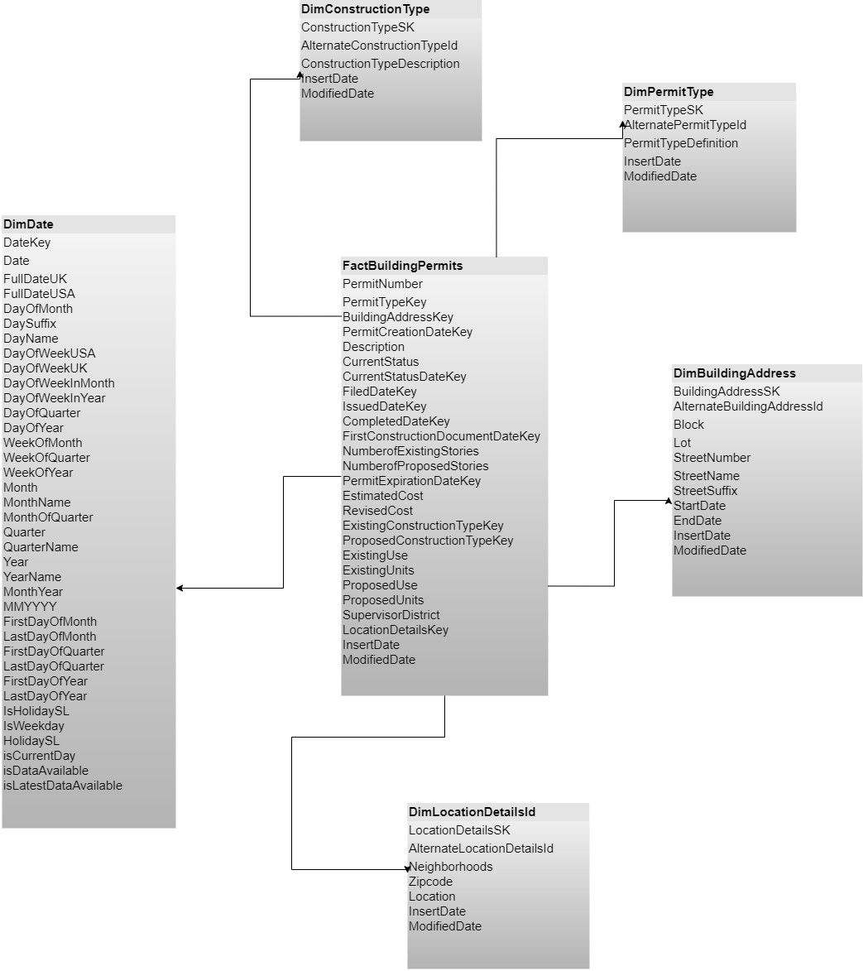

This Datawarehouse design consists of 5 different dimension table with one fact table. This is a star schema

# ❖ Assumption

I have taken **DimBuildingAddress** as **Slowly changing dimension**,Because I assume Street name can change time to time,So we need to keep track of their historical street names. After that

I had to create two drived attributes named Insertdate and ModifiedDate when I create this slowly changing dimension.

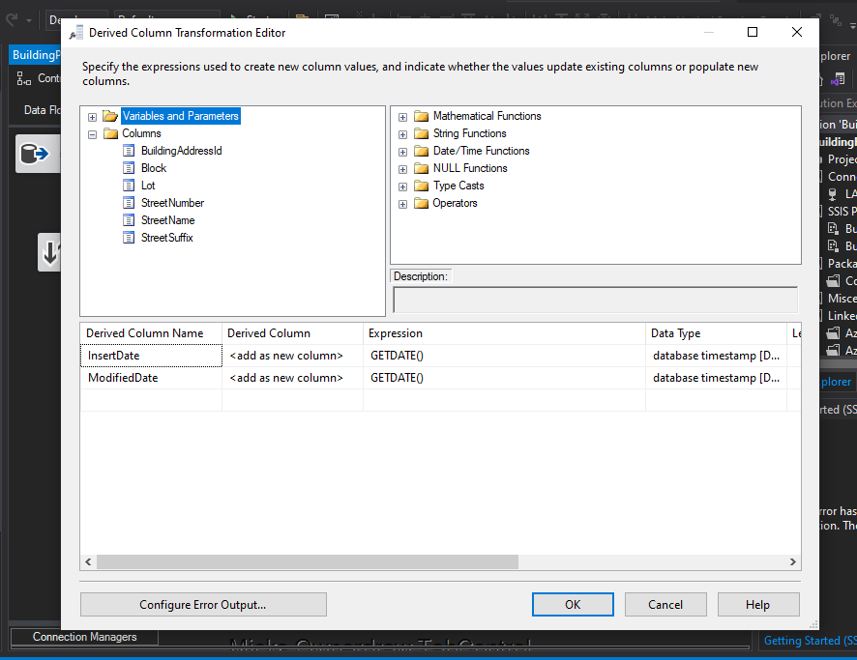

I created **NumberOfAdditionalStories** and **CostDifference** in the **factBuildingPermits** .

## • NumberOfAdditionalStories = NumberofExistingStories - NumberofProposedStories

## • CostDifference = RevisedCost – EstimatedCost

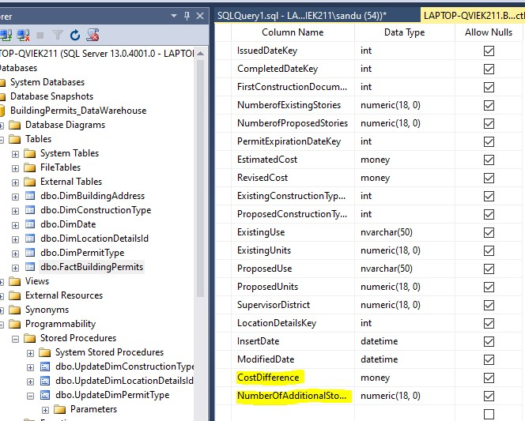

To create these two mesurable values firstly I created a stage called stg_permit to factBuilding Permit.Then I created its’ data flow task and in a derived column component I created the formula for this values.

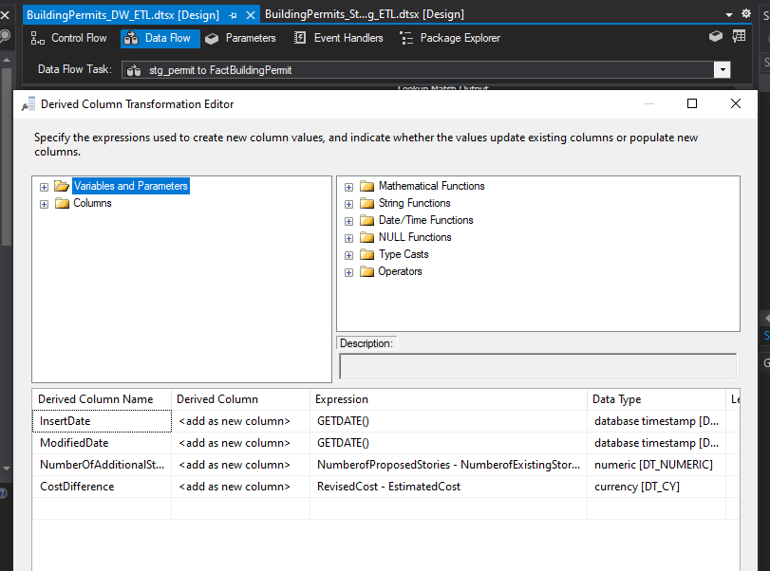

# Step 5: ETL development

In the ETL process ,I created ETL process into two Packages

They are ,

* BuildingPermits_Staging_ETL.dtsx – Source to Staging
* BuildingPermits_DW_ETL.dtsx – Staging to Datawarehouse

▪

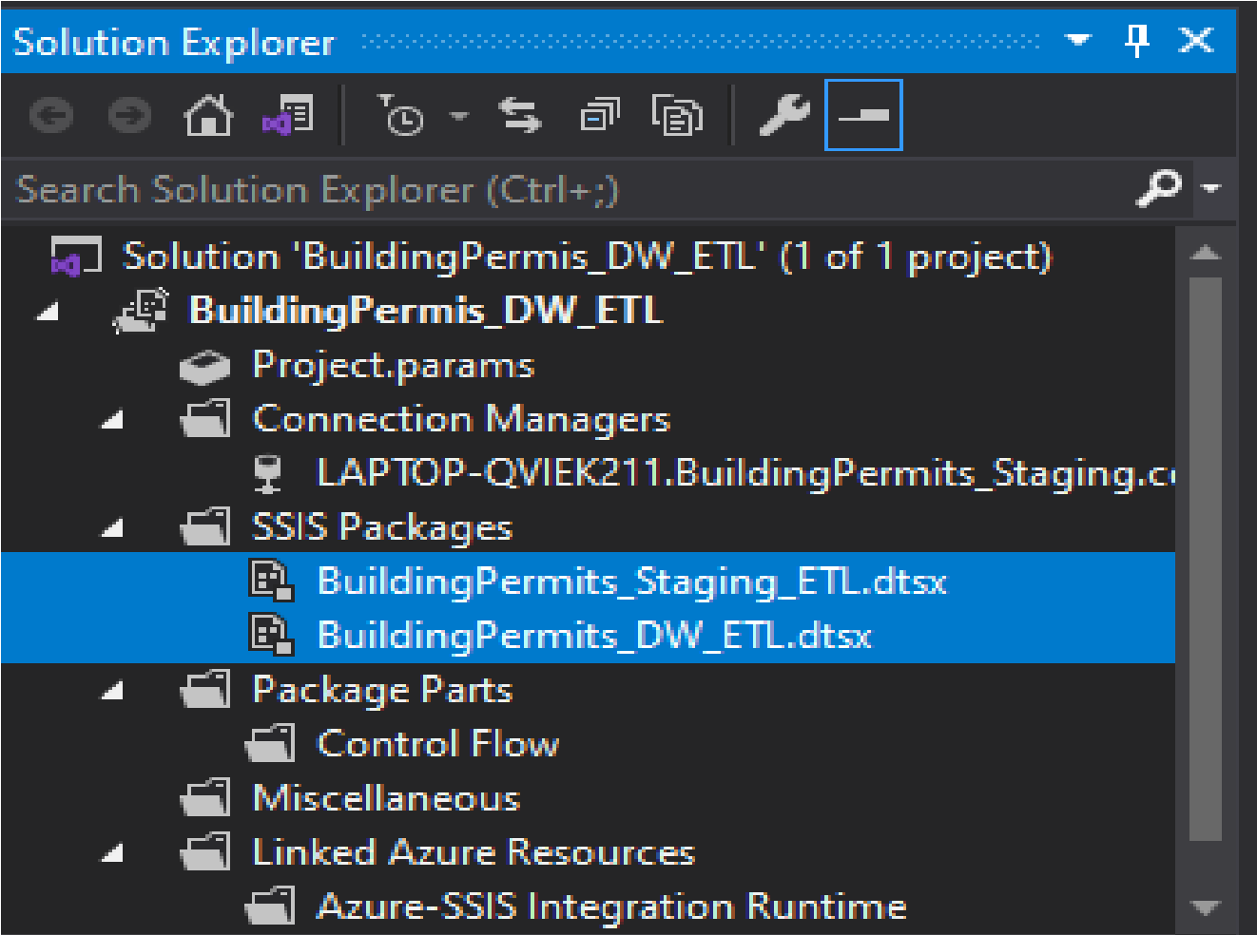

## ❖ BuildingPermits_Staging_ETL.dtsx

I created several connections in the BuildingPermits_Staging_ETL package

|  |  |
| --- | --- |
| Connection | Description |
| BuildingPermits_Staging | Connection for OLEDB |
| BuildingPermits_Sources | Connection for OLEDB |
| PermiteTypeCSVConnection | connection for platfile |
| ConstructionTypeCSVConnection | connection for platfile |
| BuildingPermitsTXTConnection | Connection for platfile |
| LocationTXTConnection | Connection for platfile |

I created

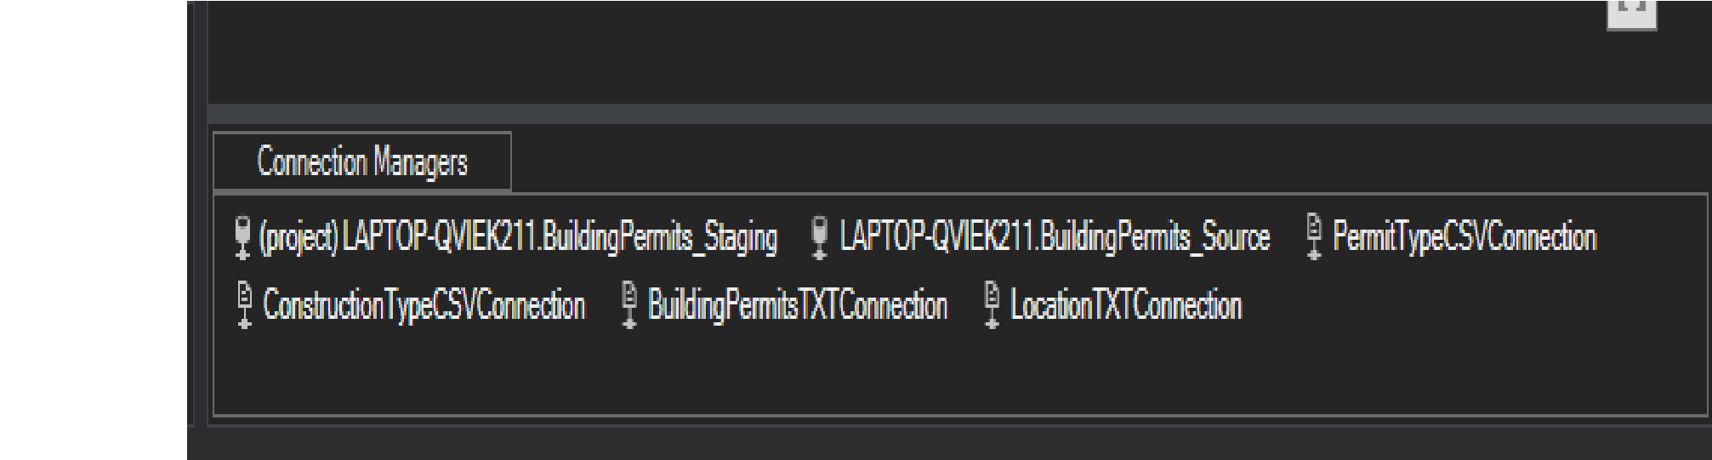

### First stage – PermitType CSV to Staging

**In the control Flow**

Firstly I created the control flow of the BuildingPermits_Staging_ETL.

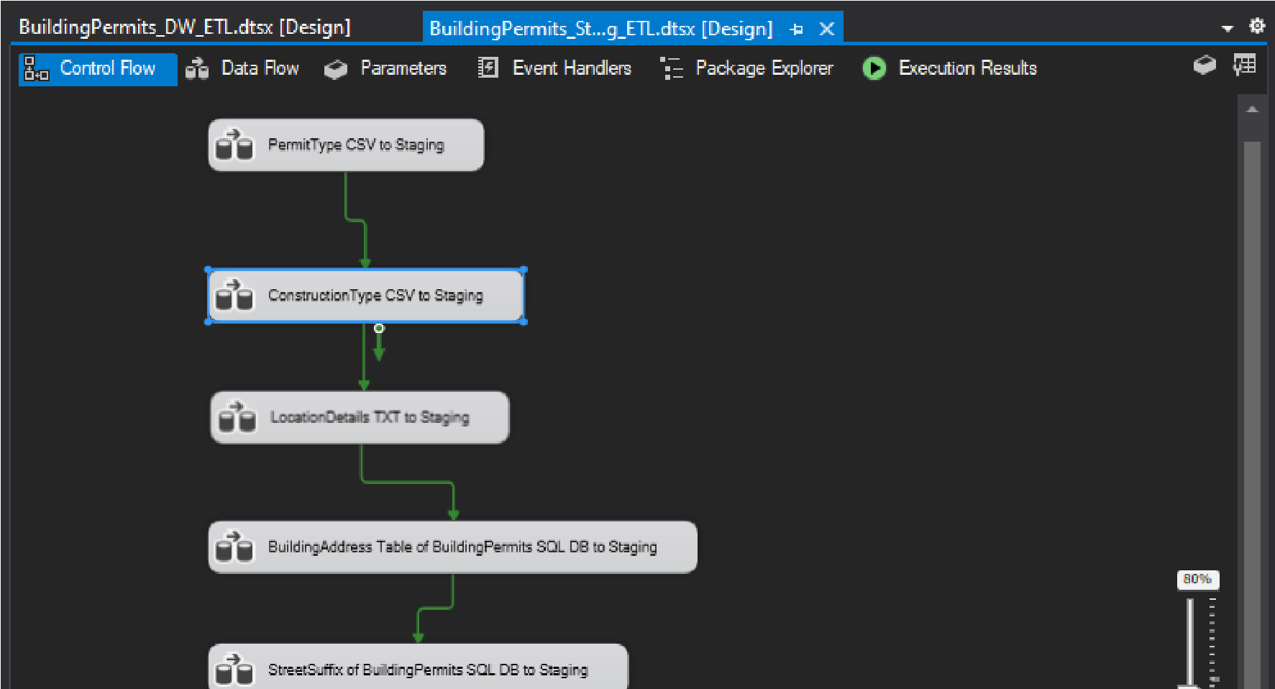

#### In the Data flow

In the PermitType CSV to staging part I created its’ data flow task configuring properties used to connect to and obtain data from a text file.

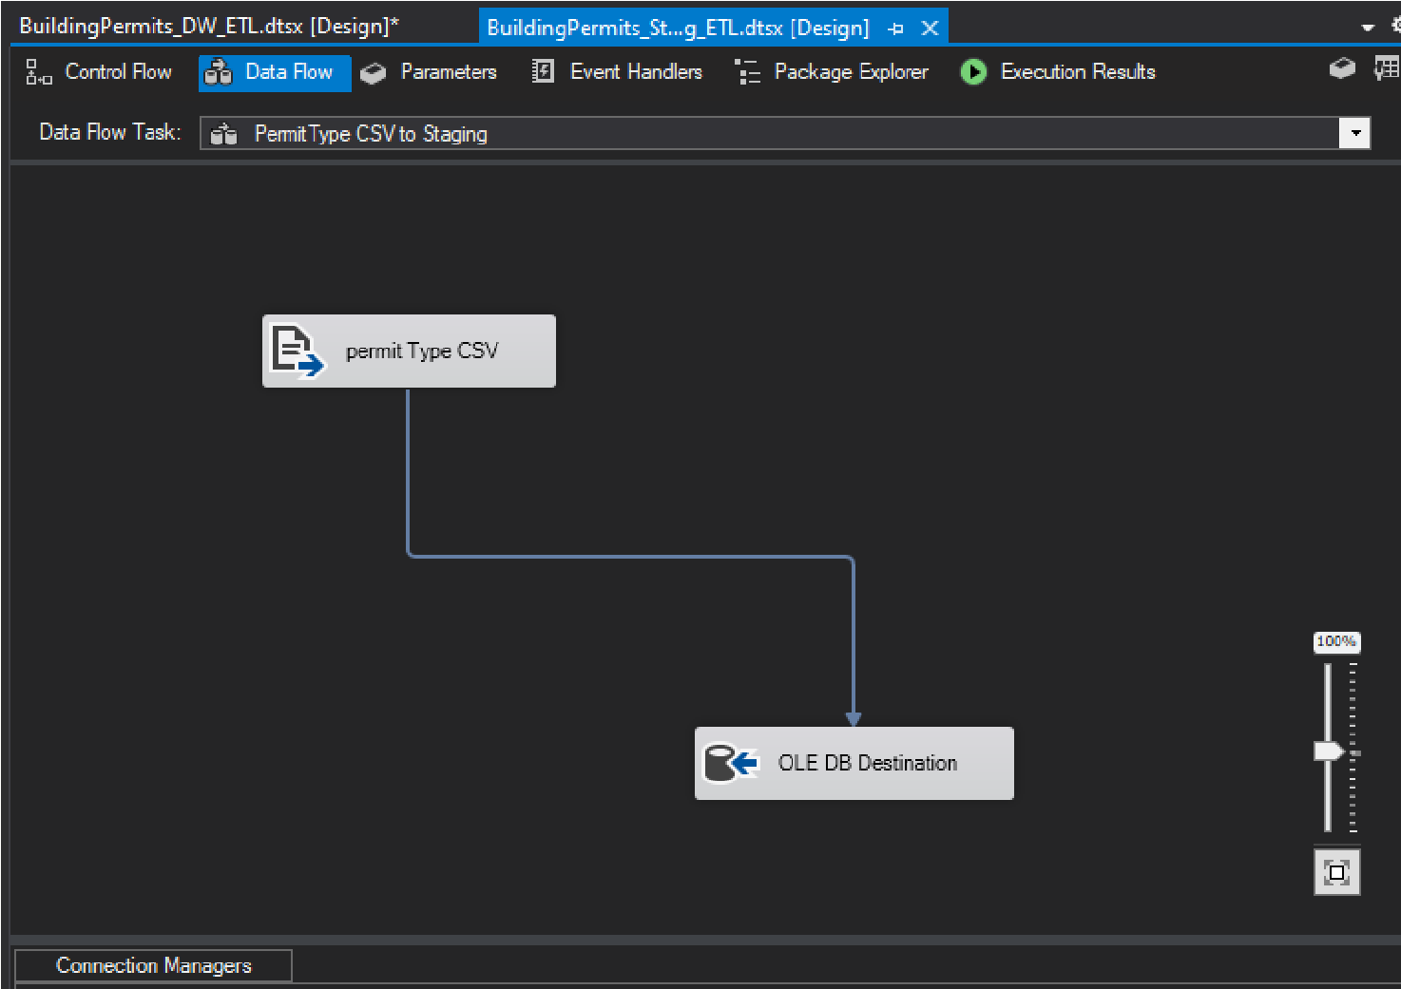

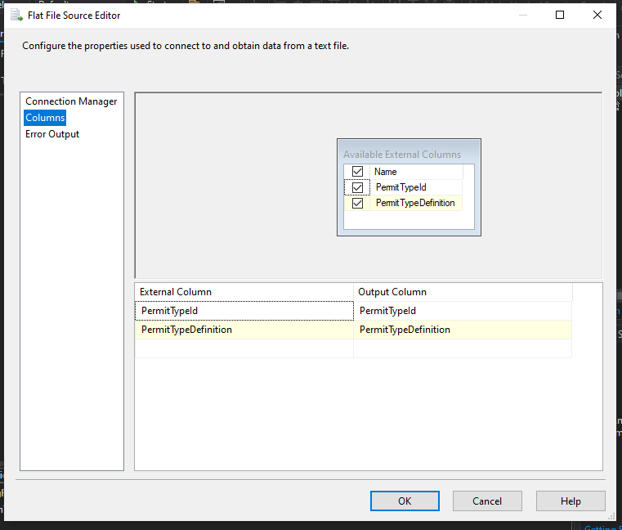

#### Using Event hanlder for first stage

Afterthat I created an event handler For it .I truncated stg_permit_type

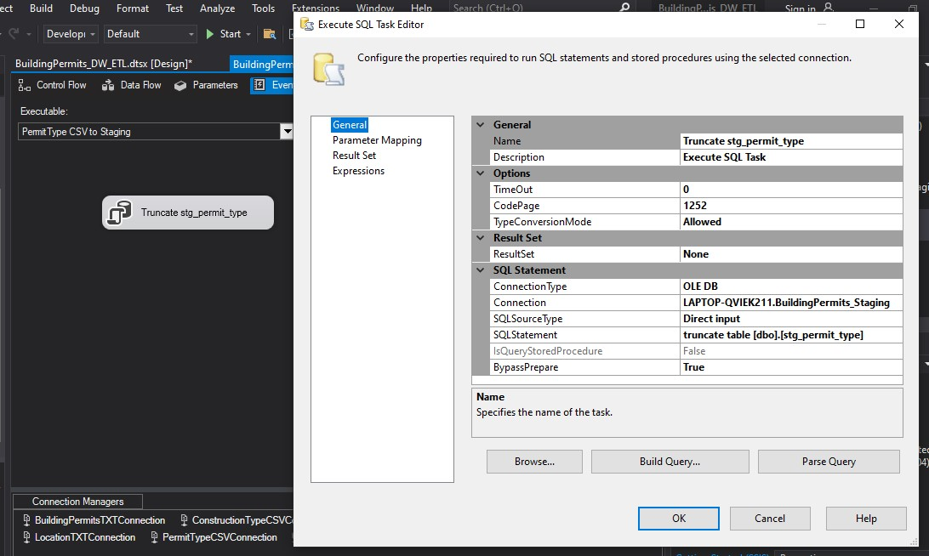

### Second stage - ConstructionType CSV to staging

After the PermitType CSV staging I created the ConstructionType to staging, configuring properties used to connect to and obtain data from a text file.

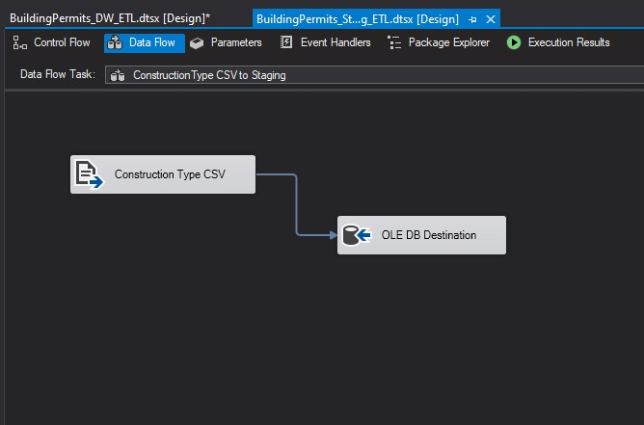

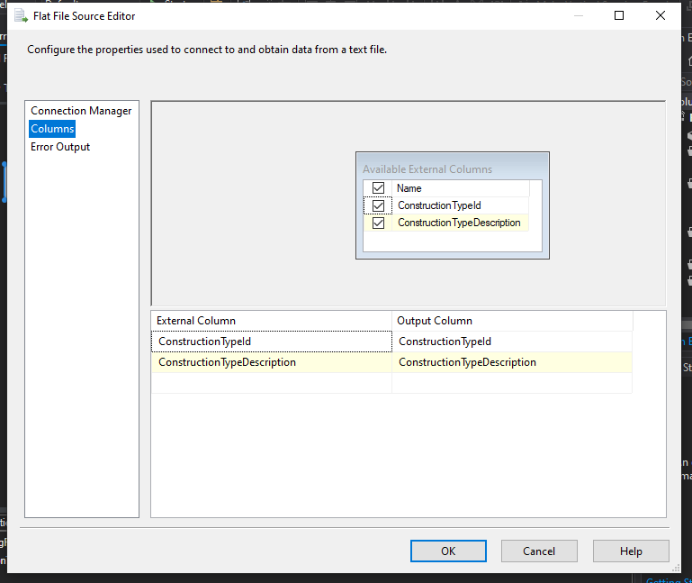

#### Using Event hanlder for the staging of ConstructionType

After creating Construction type staging I used an event handler For it .I truncated Construction type .

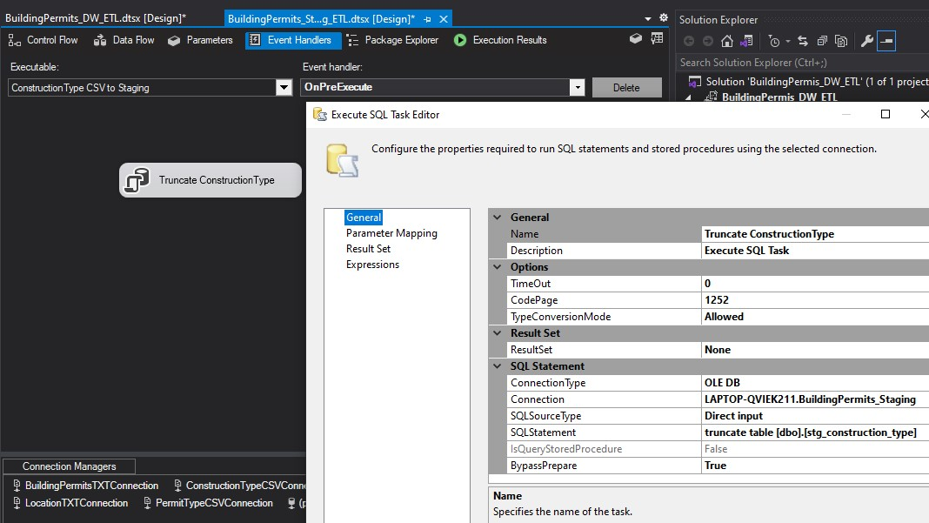

### Third Stage – LocationDetails txt to staging

Then I created LocaionDetails txt to Staging, configuring properties used to connect to and obtain data from a text file.

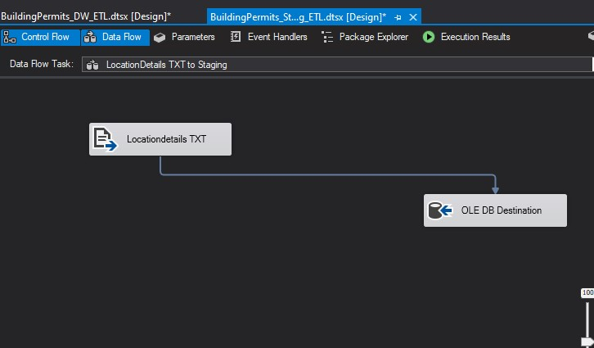

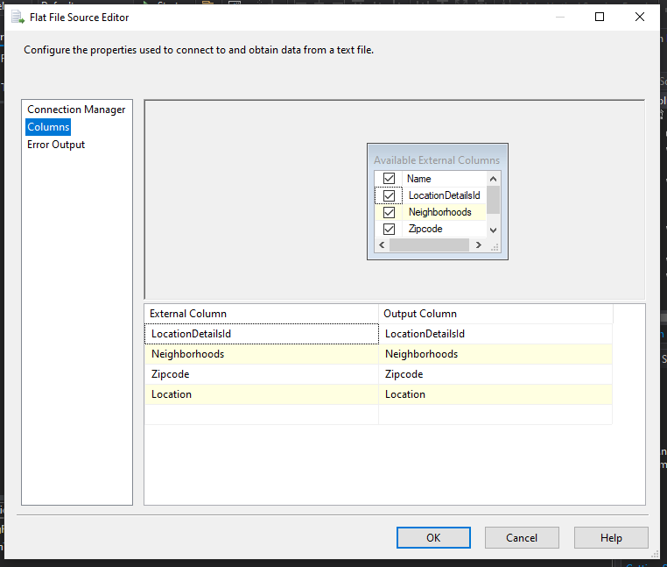

#### Using Event hanlder for the staging of LocationDetails txt

I created an event hanldler for the locationDetails staging .I truncated the location Details.

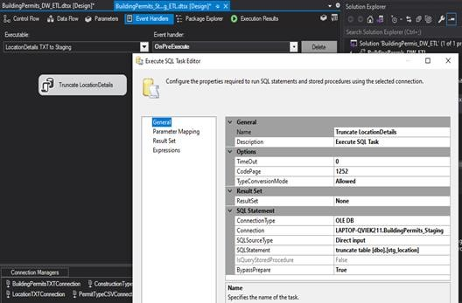

### Fourth Stage - BuildingAddress Table of BuildingPermits SQL DB to Staging

#### In the data flow

I created the data flow task of the Building address table to staging configuring properties used to connect to and obtain data from a text file.

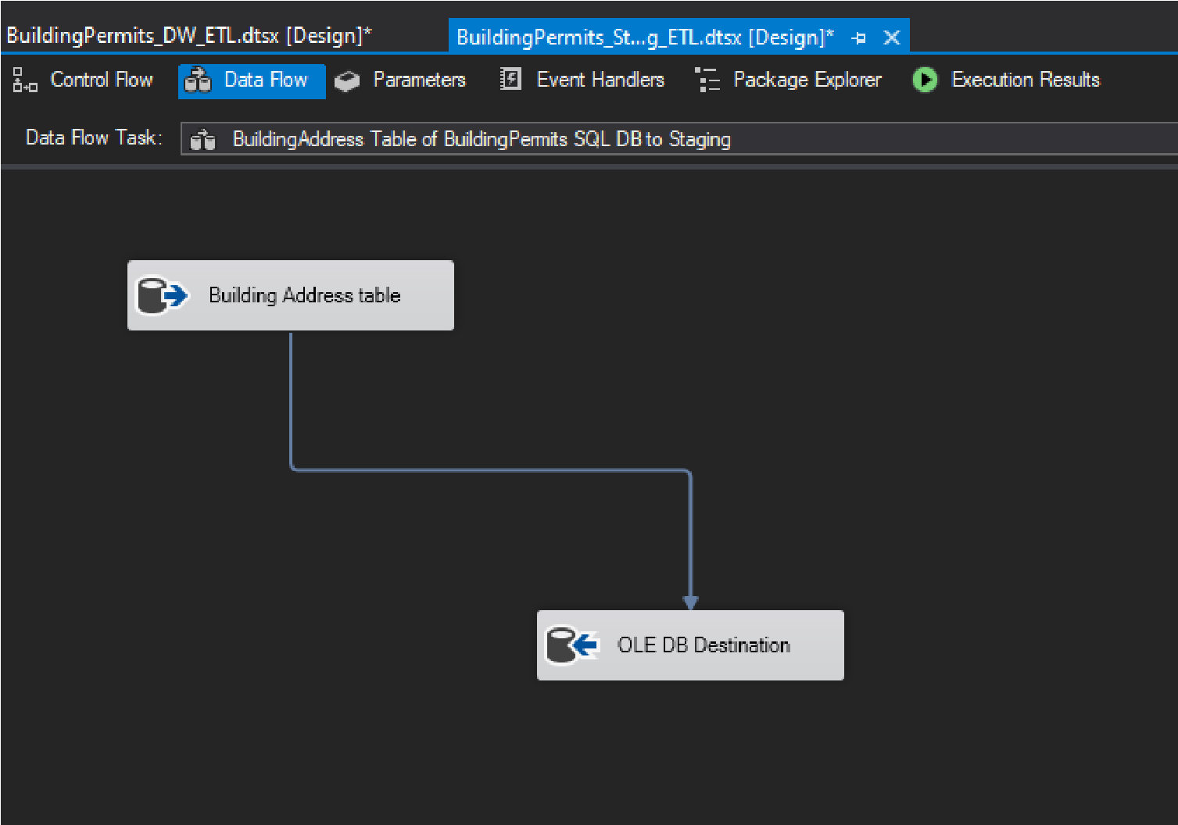

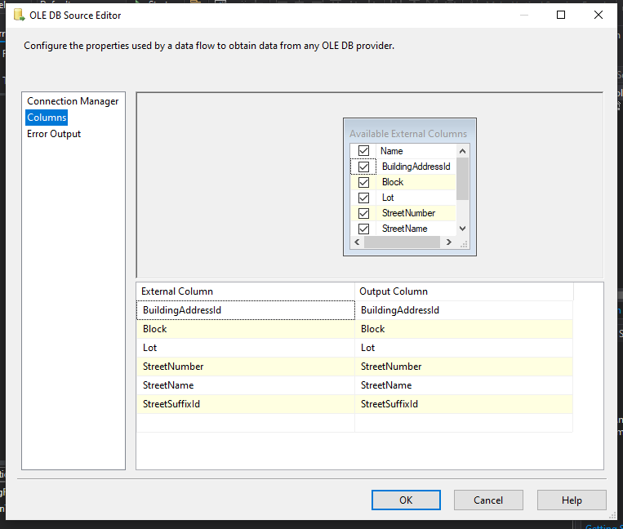

#### Using Event hanlder for the staging of BuildingAddress table of BuildingPermits SQL DB

After creating of Staging of location Details ,I truncate the Building Address table of

BuildingPermits SQL DB

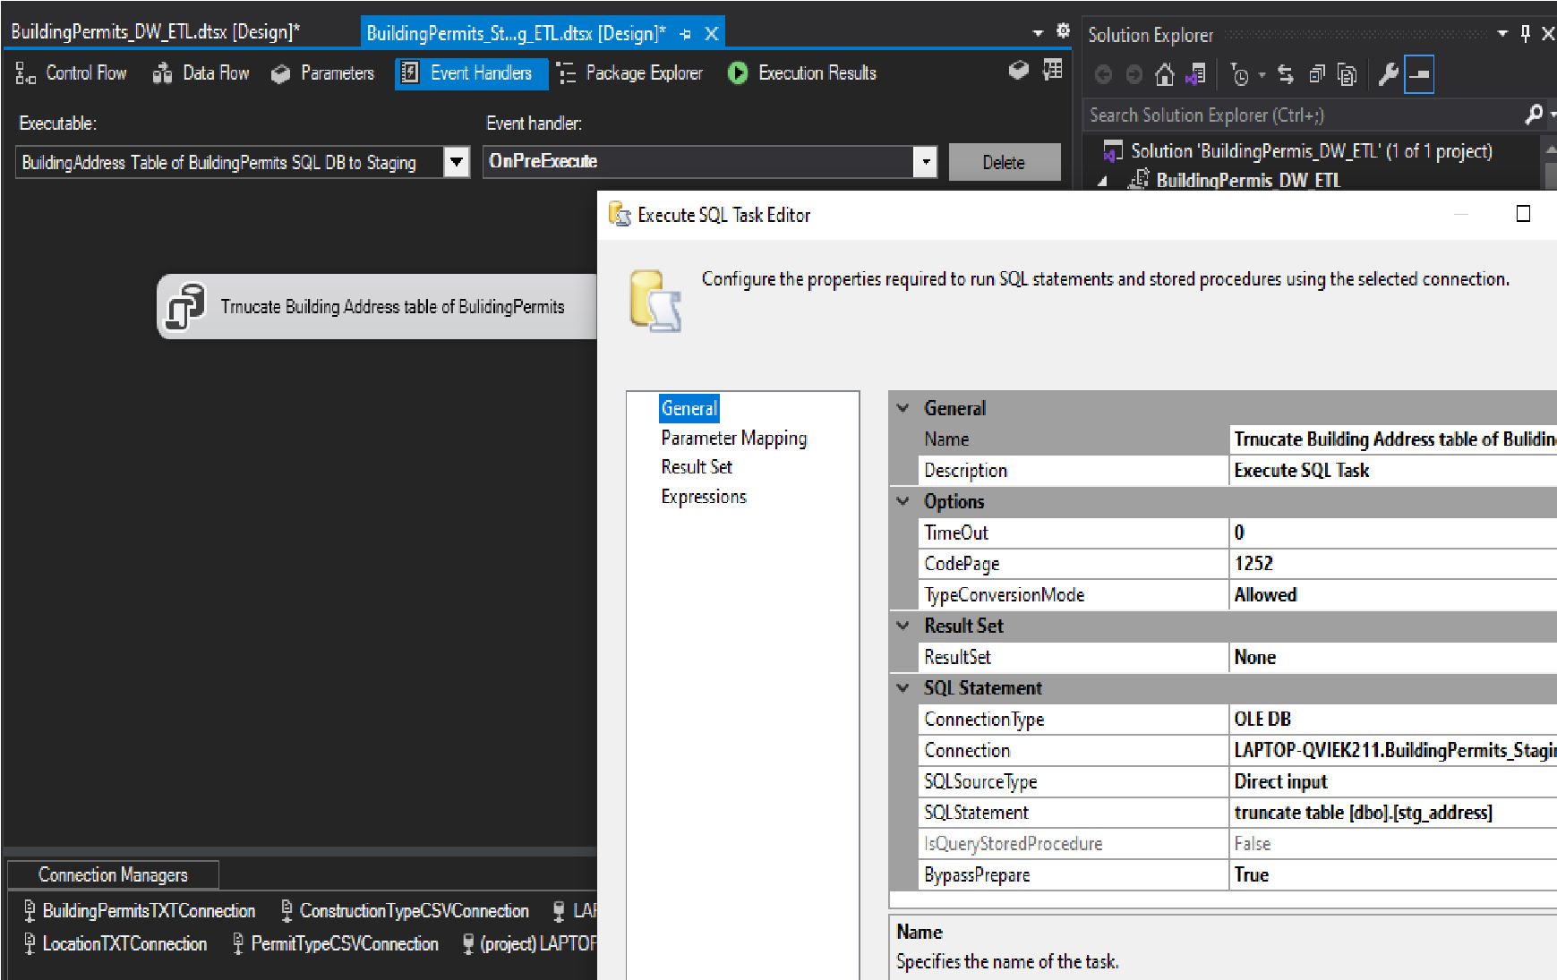

### Fifthe Stage - StreetSuffix of BuildingPermits SQL DB to Staging

After the Staging of location Details I created streetSuffix of buldingPermits SQL DB staging.

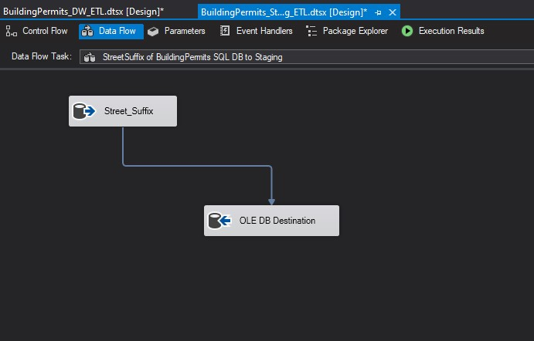

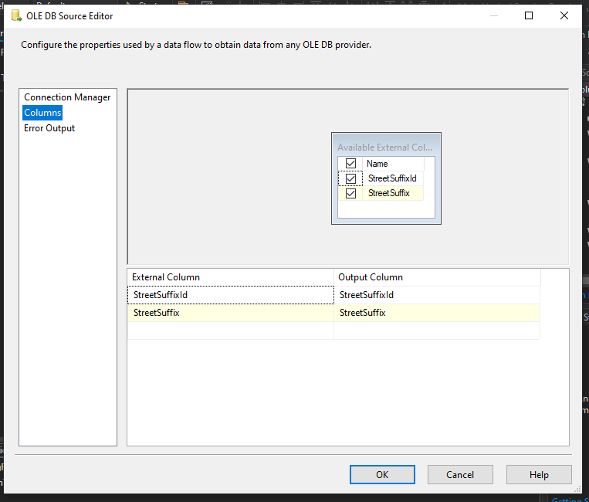

#### Using Event hanlder for the staging of Streetsuffix of BuildingPermits SQL DB Then I truncated the StreetSuffix of BuildingPermits SQL DB

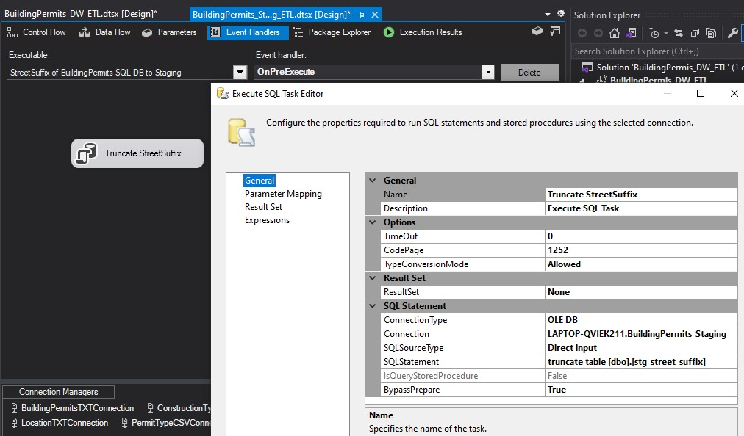

### Sixth Stage - Building Permits TXT to Staging

After staging of street suffix I designed the Building Permits TXT staging.

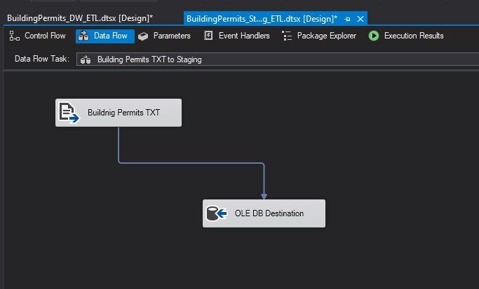

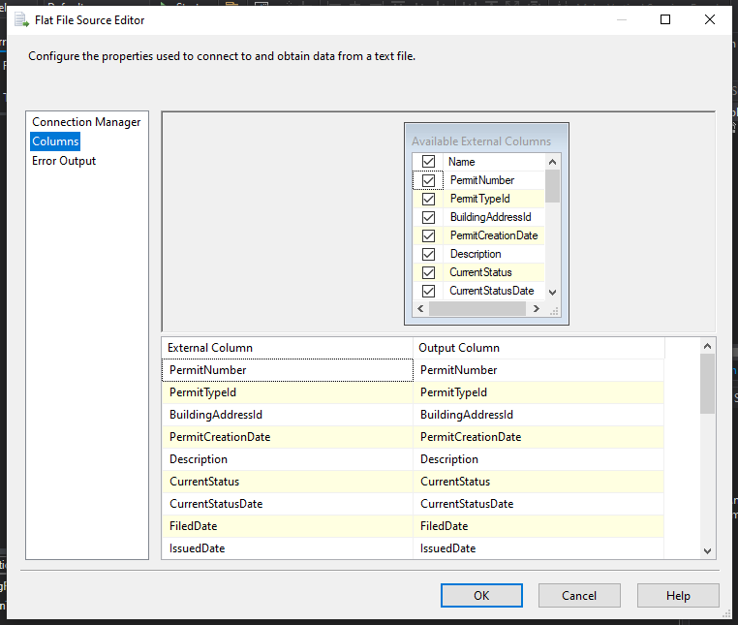

#### Using Event hanlder for the staging of Building Permits TXT

After creating the BuildingPermits staging I truncated the Building Permits

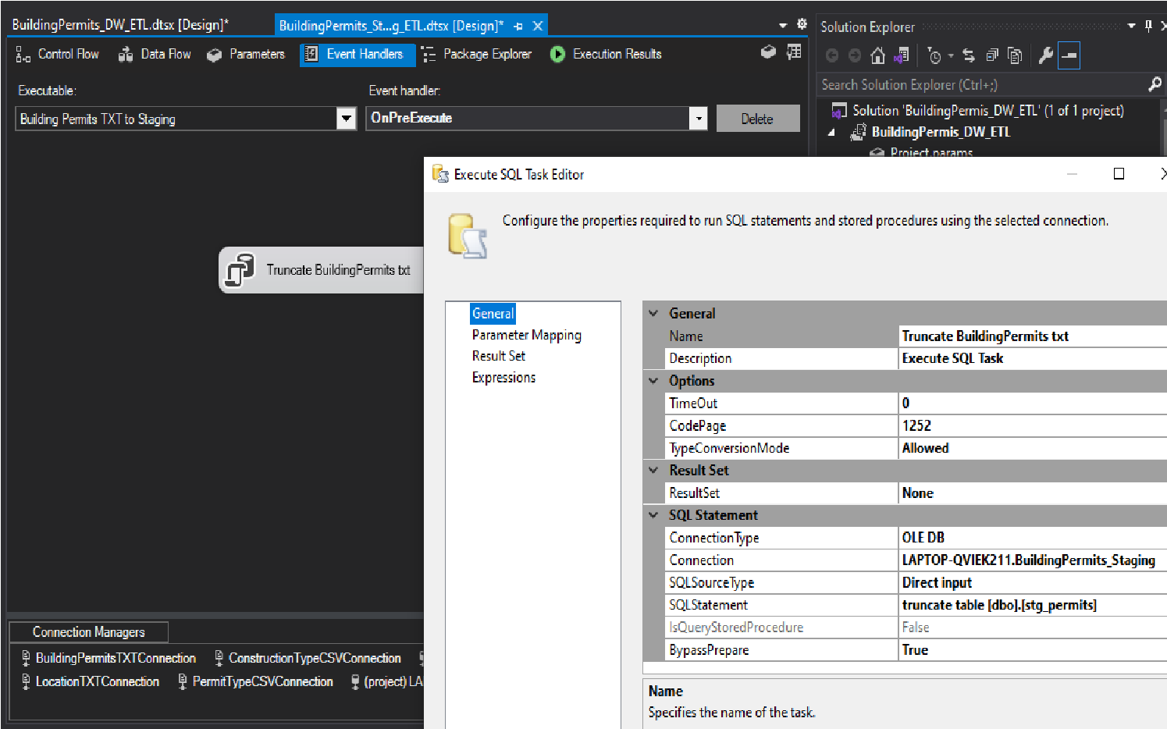

After creating staging step I create task to execute the package.

## ❖ BuildingPermits_DWH_ETL.dtsx

There are two connections in the BuildingPermits_DWH_ETL package .Because I created this package for staging to warehouse.In here I designed an another controlflow for staging to datawarehouse

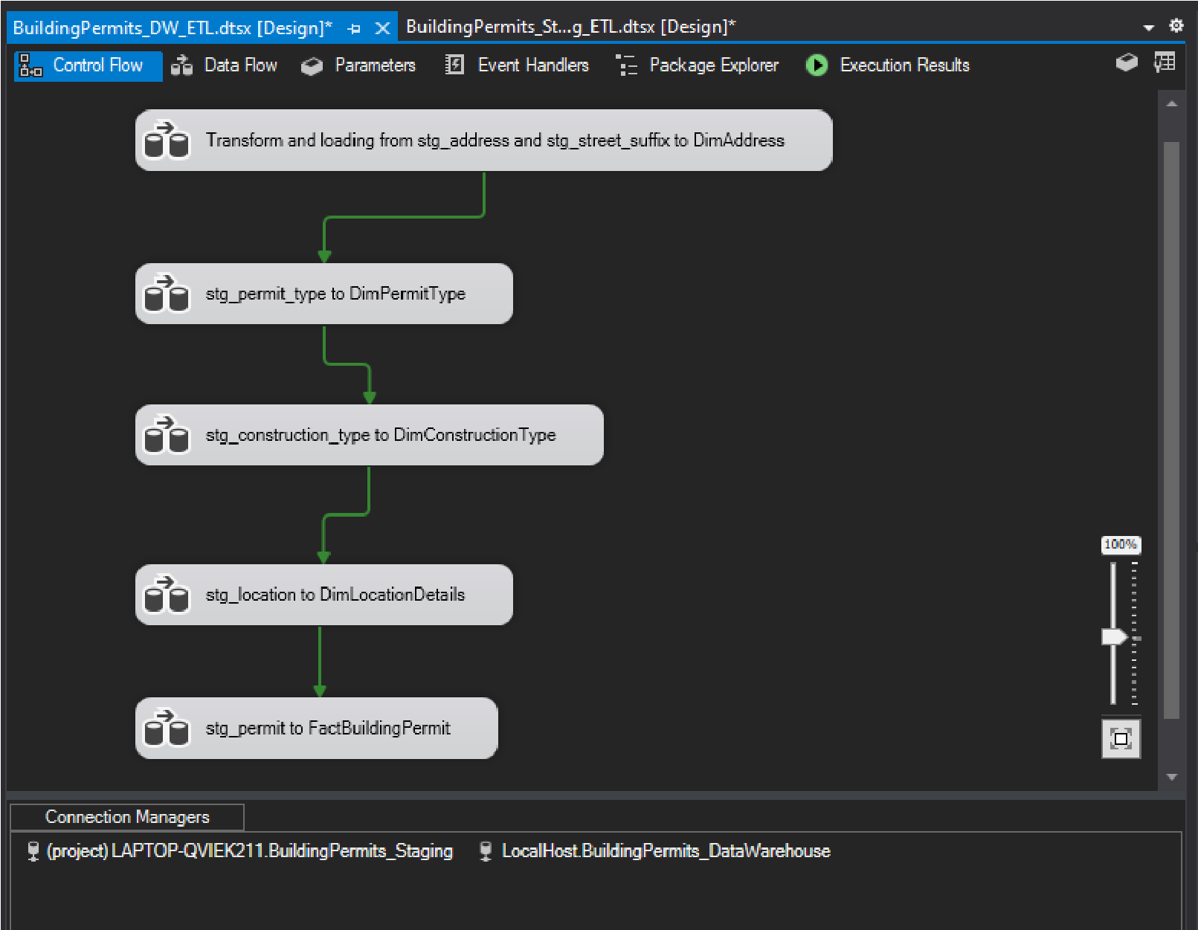

## 1.Transform and loading from stg_address and stg_street_suffix to DimBuildingAddress

In this step I created task to transform and loading staging address and street suffix to DimBuildingAddress.

In this Transform and Loading process I have to get stg_address and stg_street_suffix tables to load the DImAddress table.So I take two **sort components** using StreetSuffixId and **merge** them(stg_address table and stg_street_suffix table) and derived columns using **derived column component.**

Then I added **slowly changing dimension component** to update the DimBuildingAddress table records.

So as shown below I have transformed and loaded data

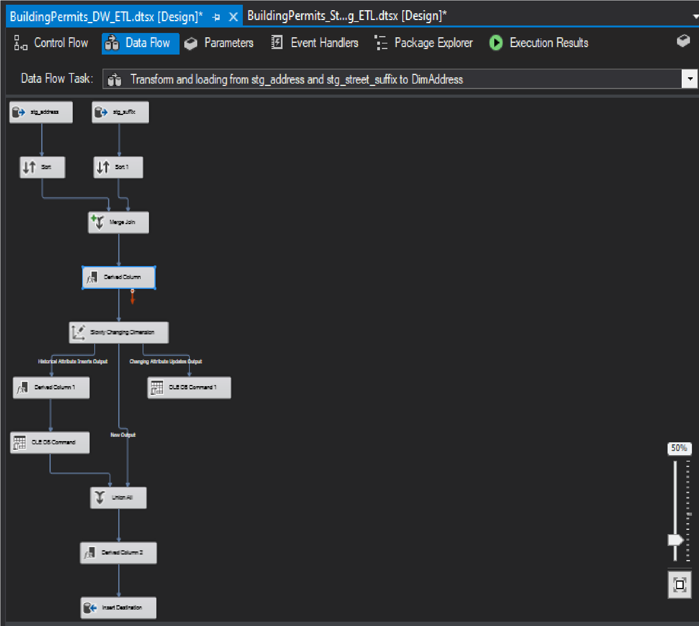

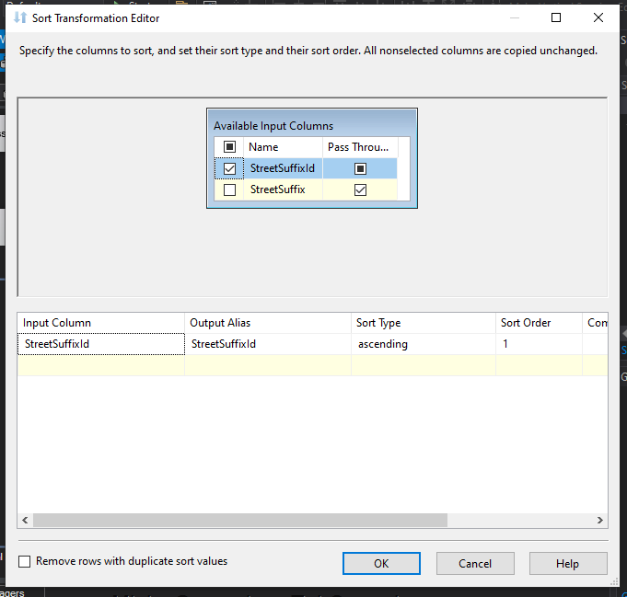

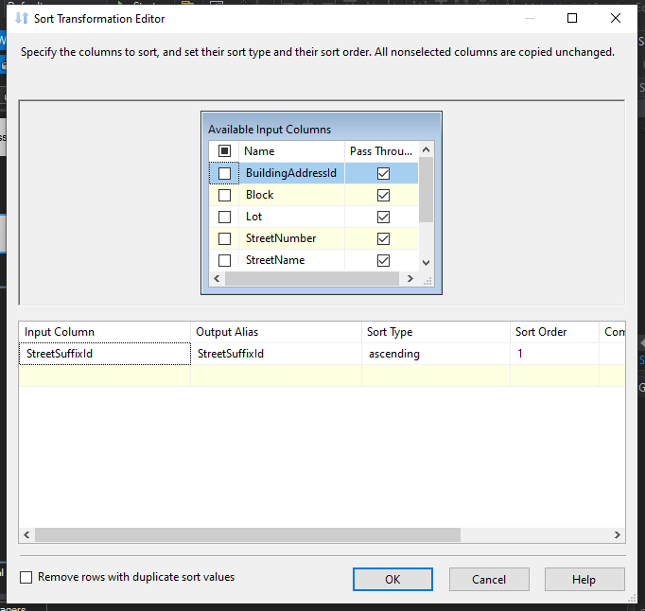

As shown belown I used merge join component to merge them.

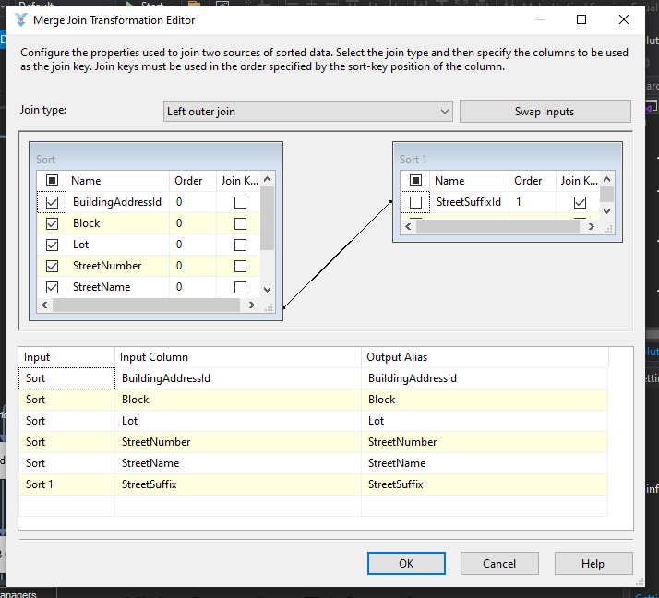

## 2.stg_permit_type to DimPermitType

I created the data flow task for stg_permit_type to DimPermitType

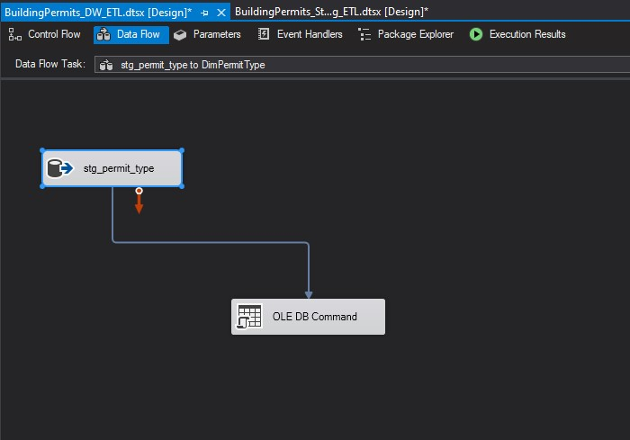

### 3. stg_construction_type to DimConstructionType

After creating the data flow task for stg_permit_type to DimPermitType ,I designed this task.

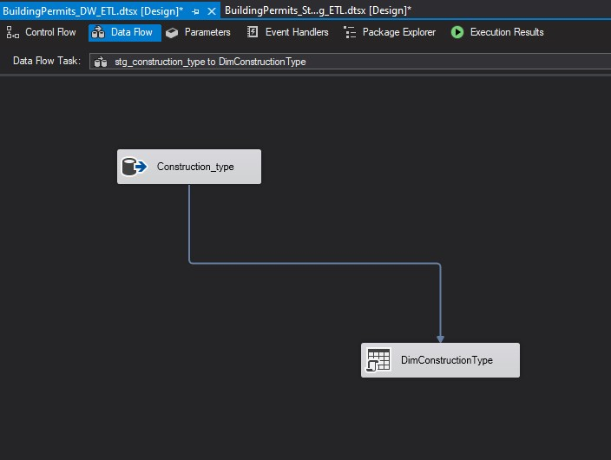

### 4. stg_location to DimLocationDetails

I created staging from stg_location to DimLocationDetails

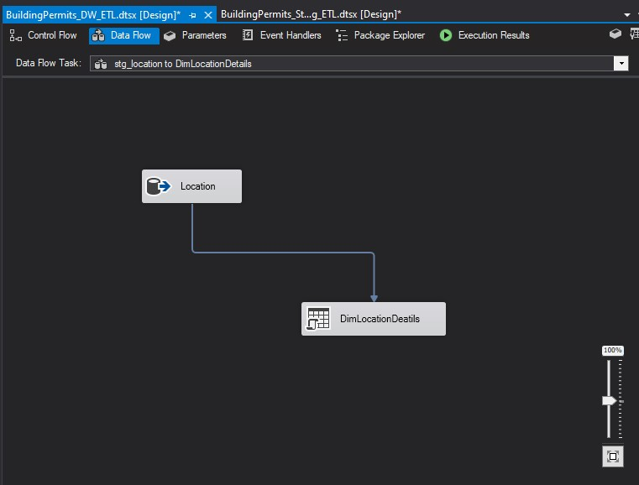

### 5. stg_permit to FactBuildingPermit

I created staging from stg_permit to FactBuildingPermit

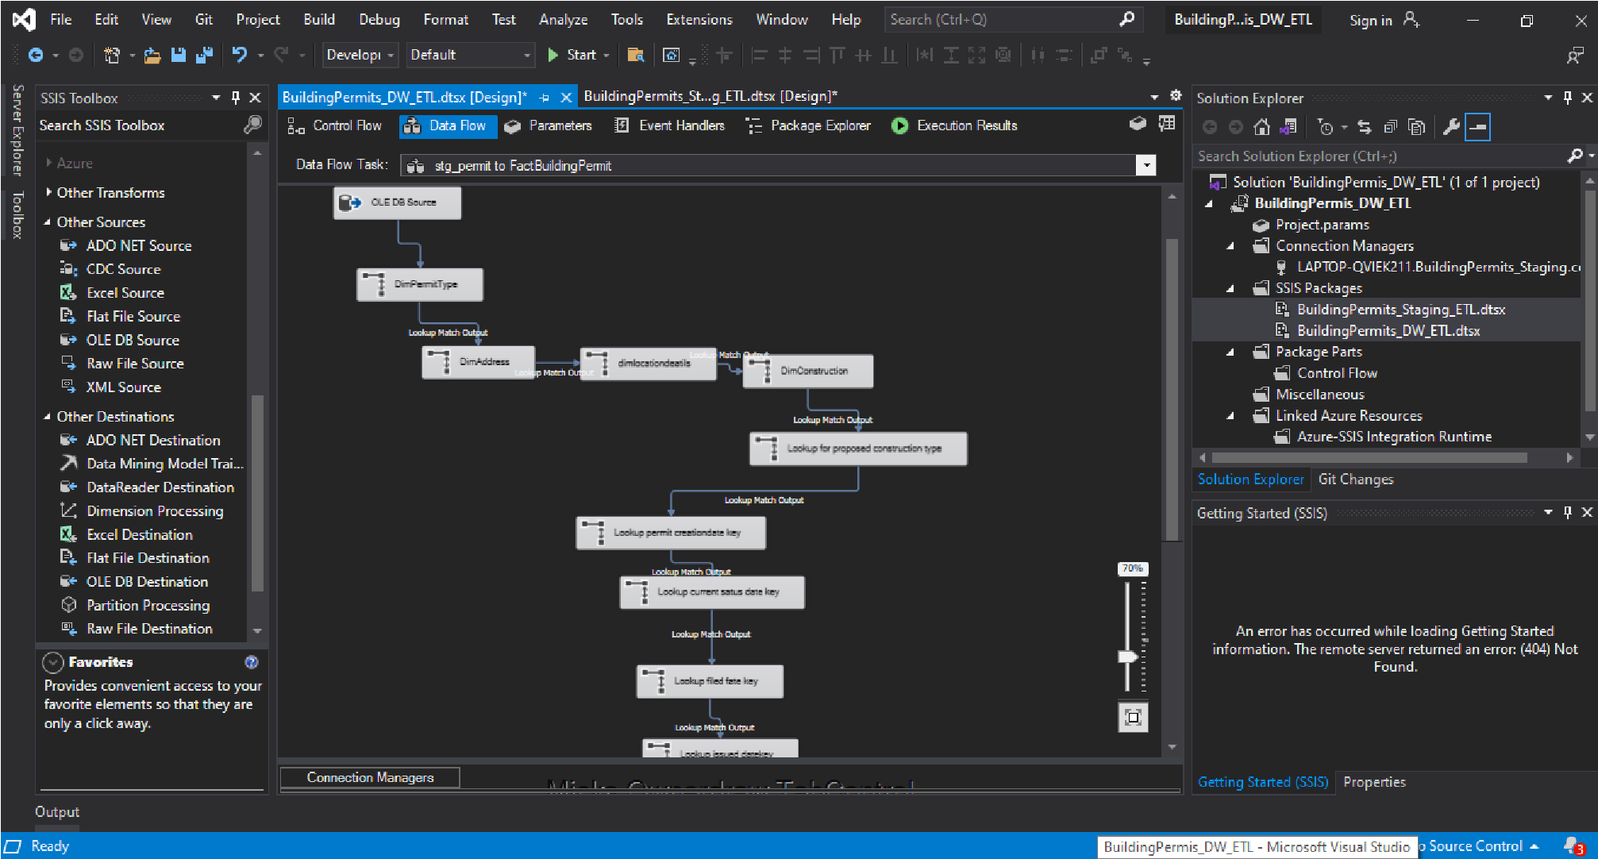

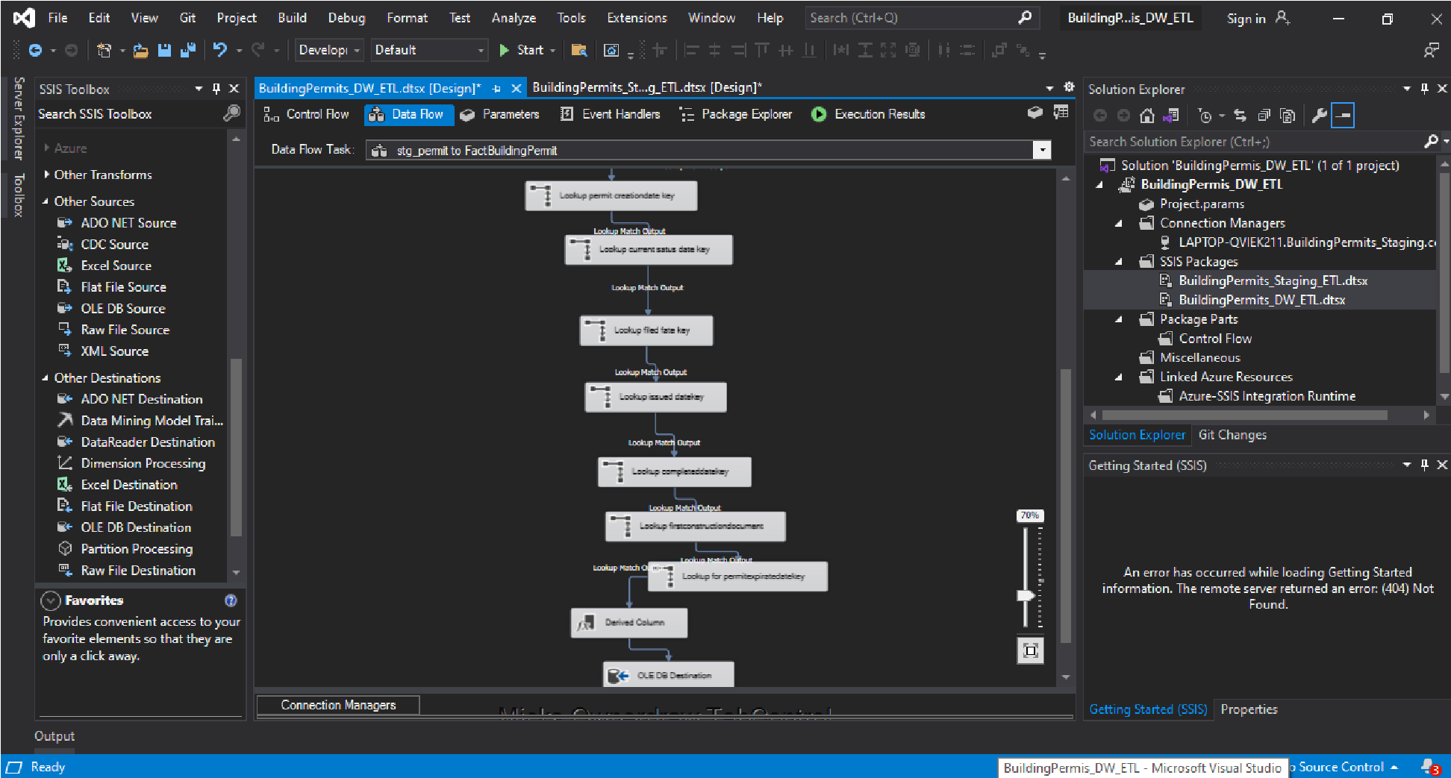

**Stored Procedures**

I have created three stored procedures in datawarehouse database as,

* UpdateDimConstructionType
* UpdateDimLocationDetailsId
* UpdateDimPermitType

### UpdateDimConstructionType

CREATE PROCEDURE dbo.UpdateDimConstructionType

@ConstructionTypeId nvarchar(8),

@ConstructionTypeDescription nvarchar(50) AS BEGIN

if not exists (select ConstructionTypeSK from dbo.dimConstructionType where AlternateConstructionTypeId = @ConstructionTypeId) BEGIN

insert into dbo.dimConstructionType (AlternateConstructionTypeId, ConstructionTypeDescription, InsertDate, ModifiedDate) values (@ConstructionTypeId, @ConstructionTypeDescription, GETDATE(), GETDATE())

END;

if exists (select ConstructionTypeSK from dbo.dimConstructionType where AlternateConstructionTypeId = @ConstructionTypeId) BEGIN

update dbo.dimConstructionType set ConstructionTypeDescription =

@ConstructionTypeDescription, ModifiedDate = GETDATE() where AlternateConstructionTypeId = @ConstructionTypeId

END;

END;

EXEC dbo.UpdateDimConstructionType ?, ?

### UpdateDimLocationDetailsId

CREATE PROCEDURE dbo.UpdateDimLocationDetailsId

@LocationDetailsId nvarchar(8),

@Neighborhoods nvarchar(50),

@Zipcode numeric,

@Location nvarchar(50) AS BEGIN

if not exists (select LocationDetailsSK from dbo.dimLocationDetailsId where AlternateLocationDetailsId = @LocationDetailsId) BEGIN

insert into dbo.dimLocationDetailsId (AlternateLocationDetailsId,

Neighborhoods,Zipcode,Location , InsertDate, ModifiedDate) values

(@LocationDetailsId,@Neighborhoods,@Zipcode,@Location, GETDATE(), GETDATE())

END;

if exists (select LocationDetailsSK from dbo.dimLocationDetailsId where AlternateLocationDetailsId = @LocationDetailsId) BEGIN

update dbo.dimLocationDetailsId set Neighborhoods =

@Neighborhoods,Zipcode=@Zipcode ,Location=@Location, ModifiedDate = GETDATE() where

AlternateLocationDetailsId = @LocationDetailsId

END;

END;

EXEC dbo.UpdateDimLocationDetailsId ?, ?, ?, ?

### UpdateDimPermitType

CREATE PROCEDURE dbo.UpdateDimPermitType

@PermitTypeId nvarchar(8),

@PermitTypeDefinition nvarchar(50) AS BEGIN

if not exists (select PermitTypeSK from dbo.dimPermitType where AlternatePermitTypeId = @PermitTypeId)

BEGIN

insert into dbo.dimPermitType (AlternatePermitTypeId, PermitTypeDefinition, InsertDate, ModifiedDate) values (@PermitTypeId, @PermitTypeDefinition, GETDATE(), GETDATE())

END;

if exists (select PermitTypeSK from dbo.dimPermitType where AlternatePermitTypeId = @PermitTypeId)

BEGIN

update dbo.dimPermitType set PermitTypeDefinition = @PermitTypeDefinition, ModifiedDate = GETDATE() where AlternatePermitTypeId = @PermitTypeId

END;

END;

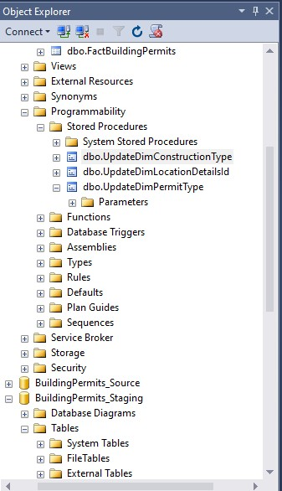

EXEC dbo.UpdateDimPermitType ?, ?

#### BuildingPermits_DataWarehouse BuildingPermits_Source BuildingPermits_Staging

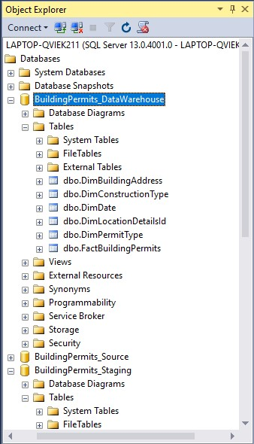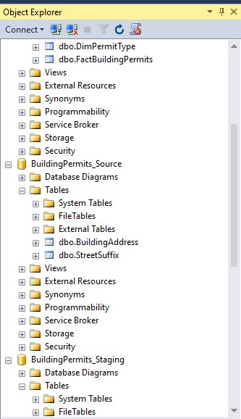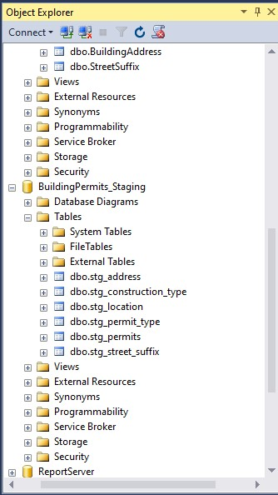

Tables of the BuildingPermits_Staging

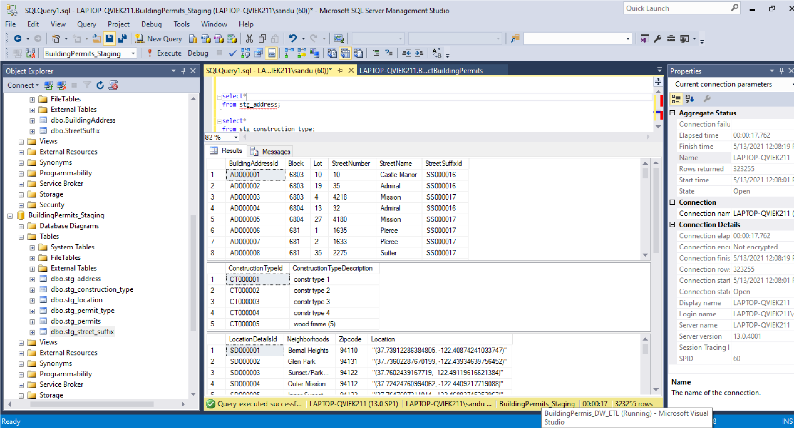

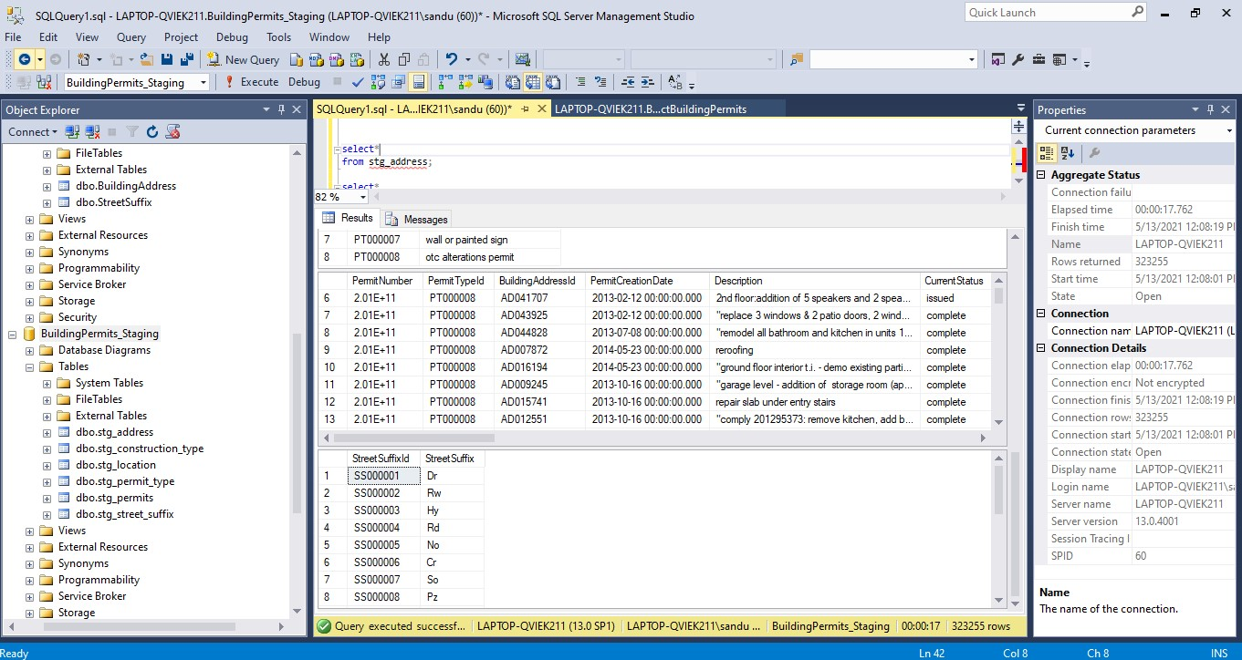

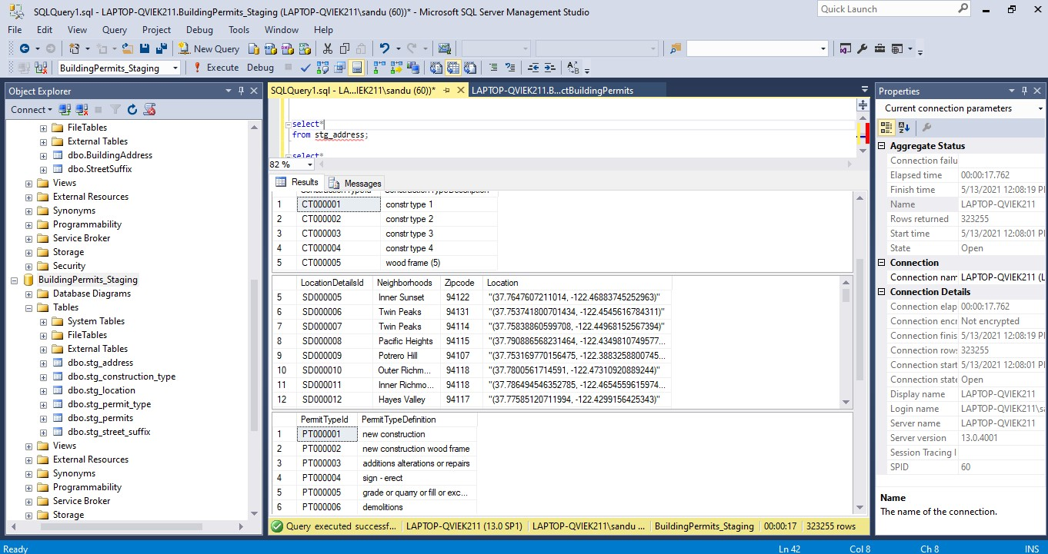

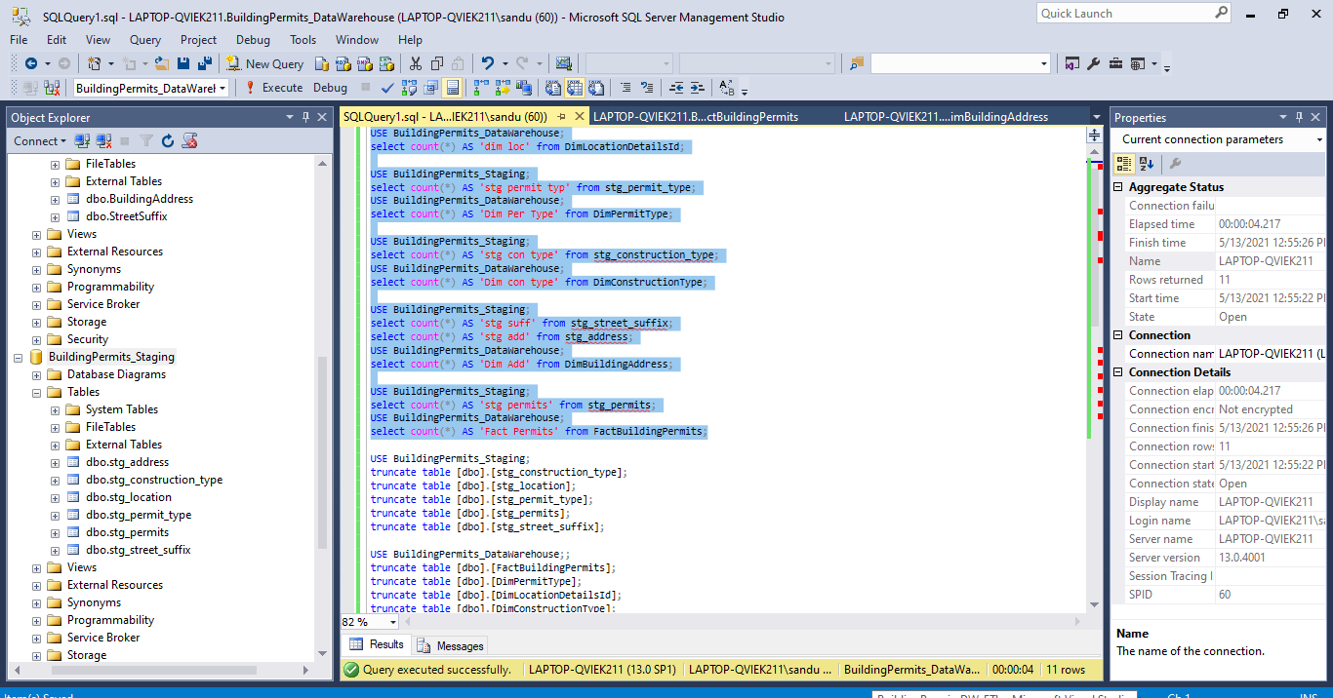

These errors occured while I was designing the datawarehouse

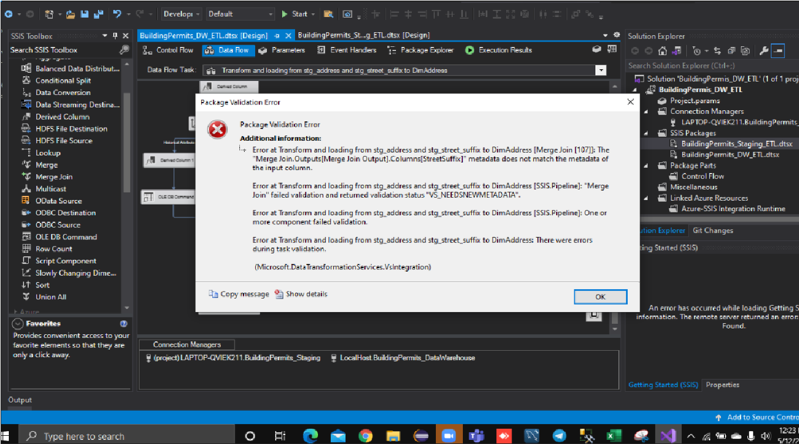

I

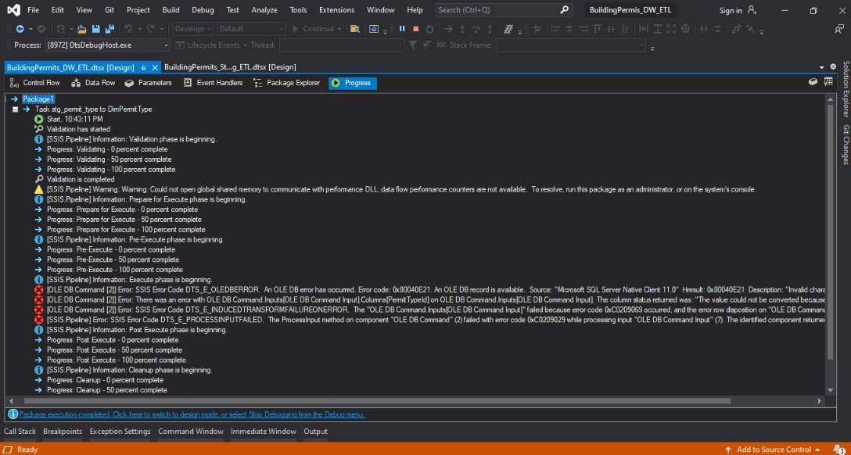

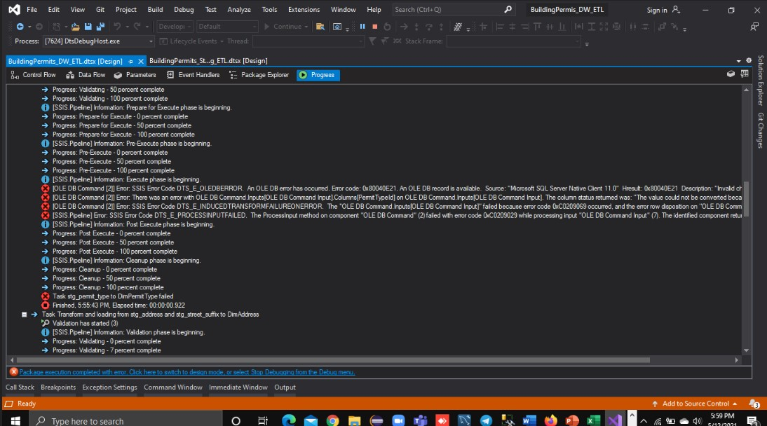

**After the Excution of the full packages**

We created the datawarehouse successfully

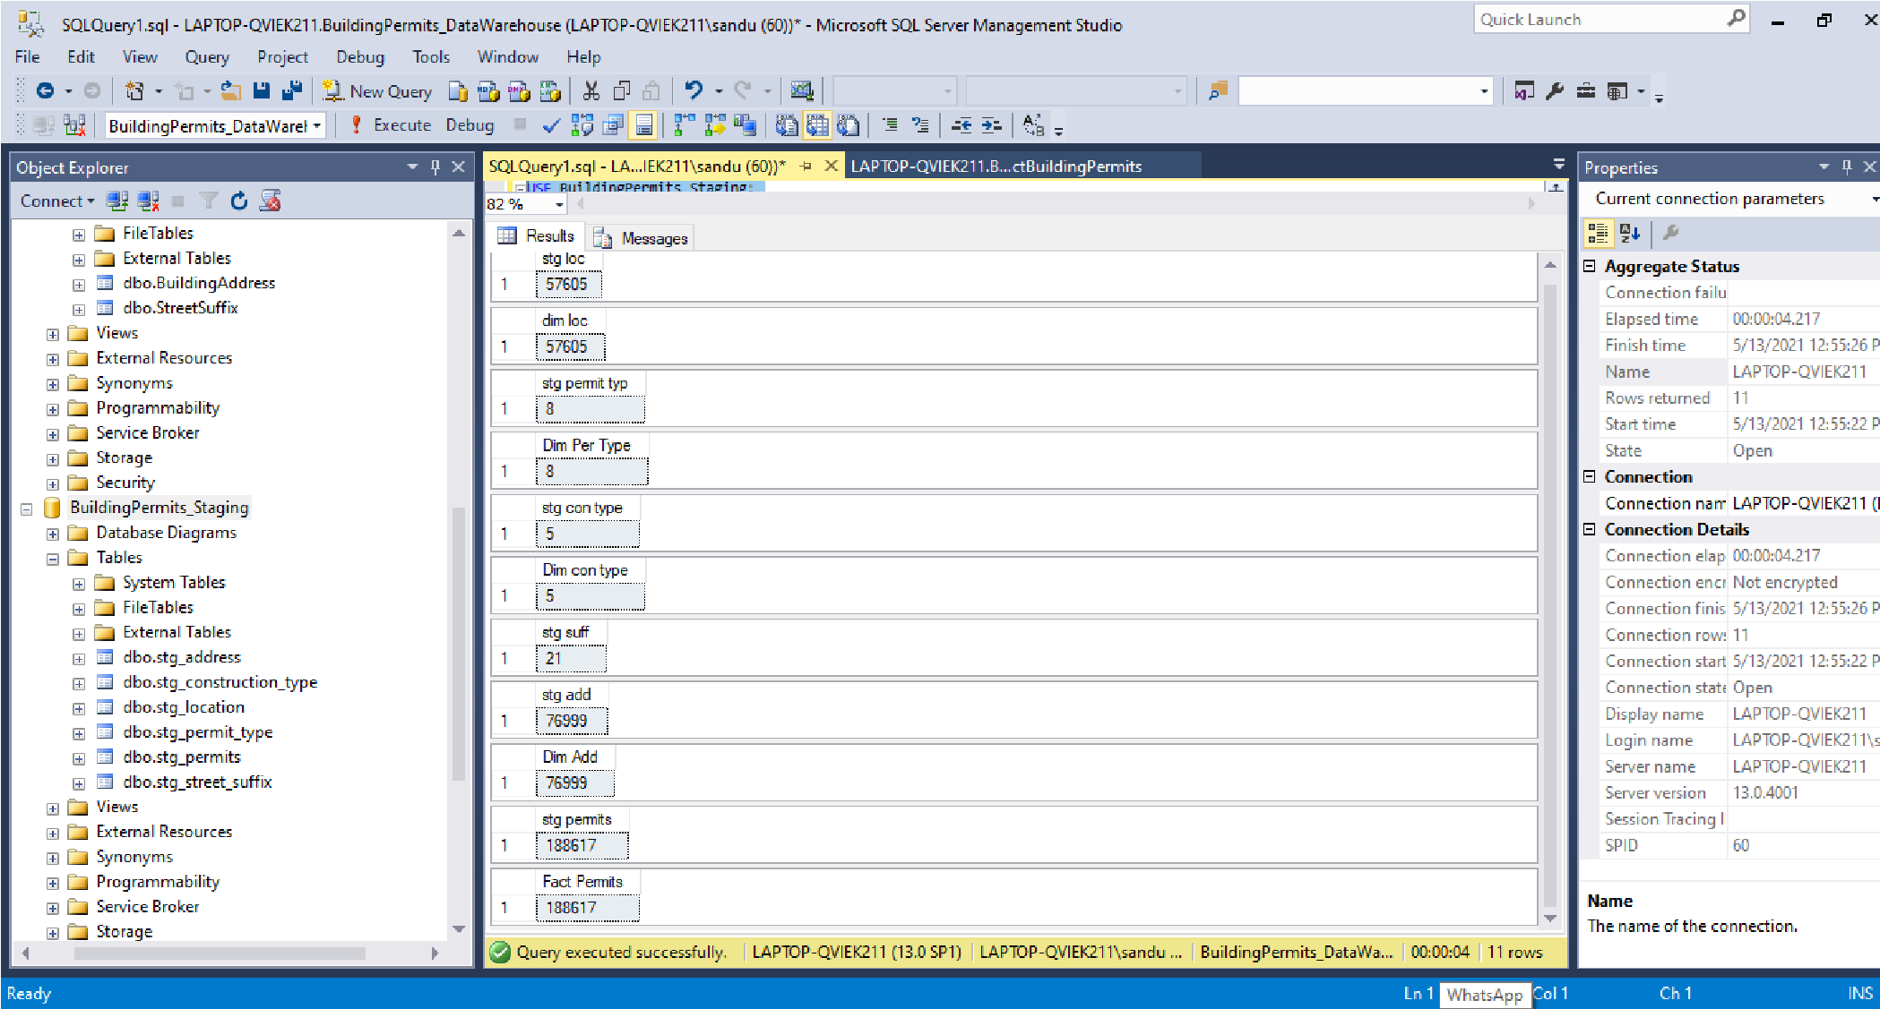

**BuildingPermits_Staging_ETL.dtsx**

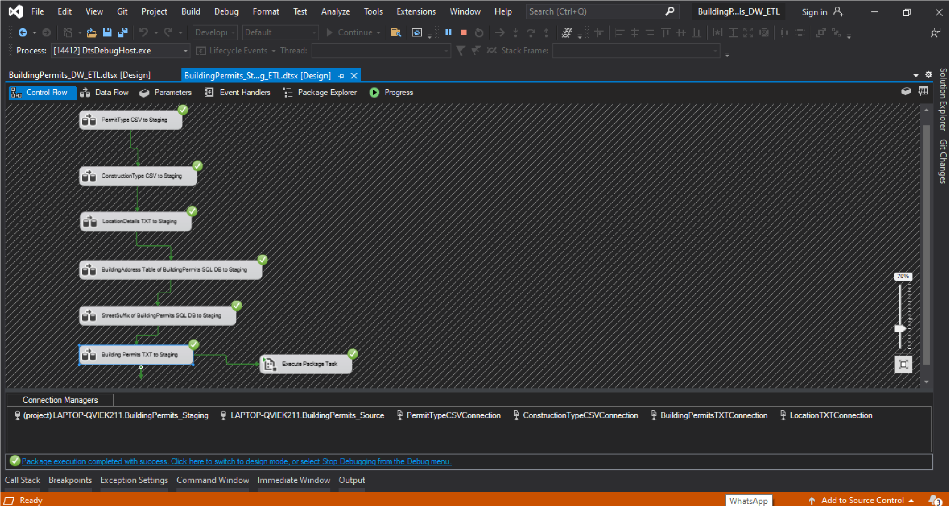

**Building Permits txt to staging**

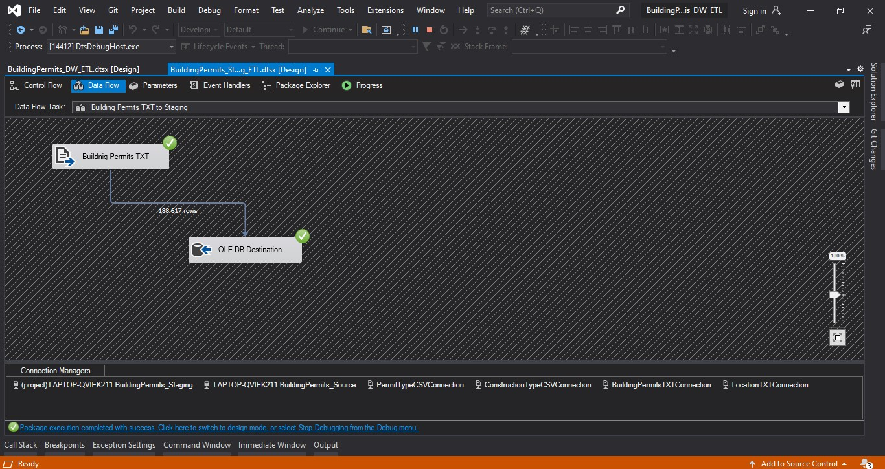

* **StreetSuffix of Building Permits SQL DB to Staging**

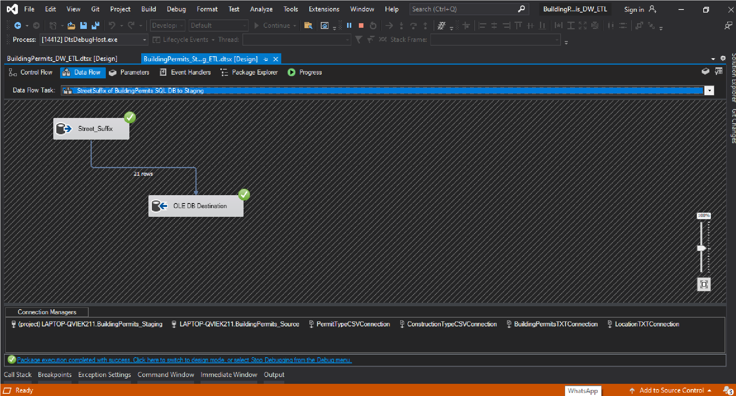

**Building Address table of Building Permits SQL DB to Staging**

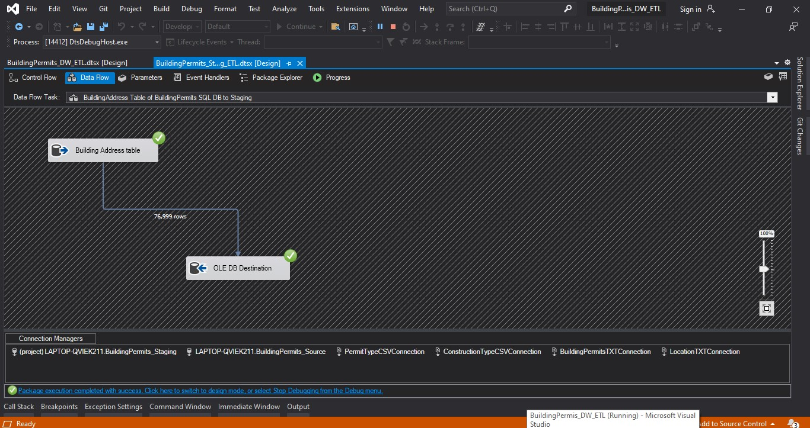

**LocationFeatils txt to staging**

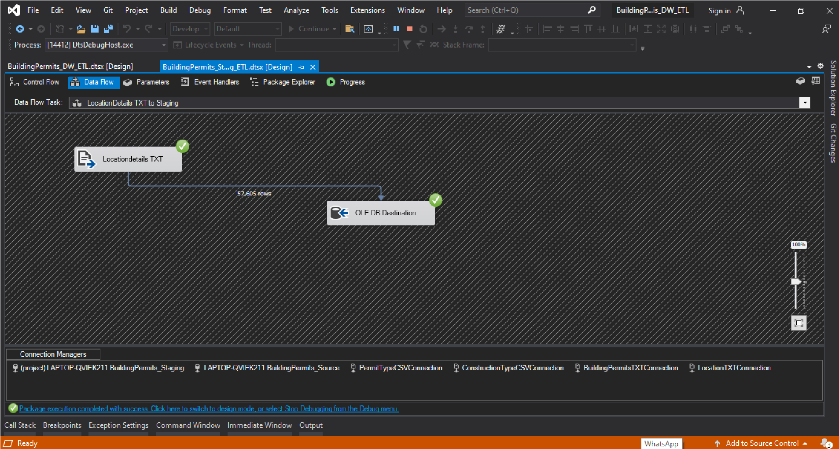

# • ConstructionType csv to staging

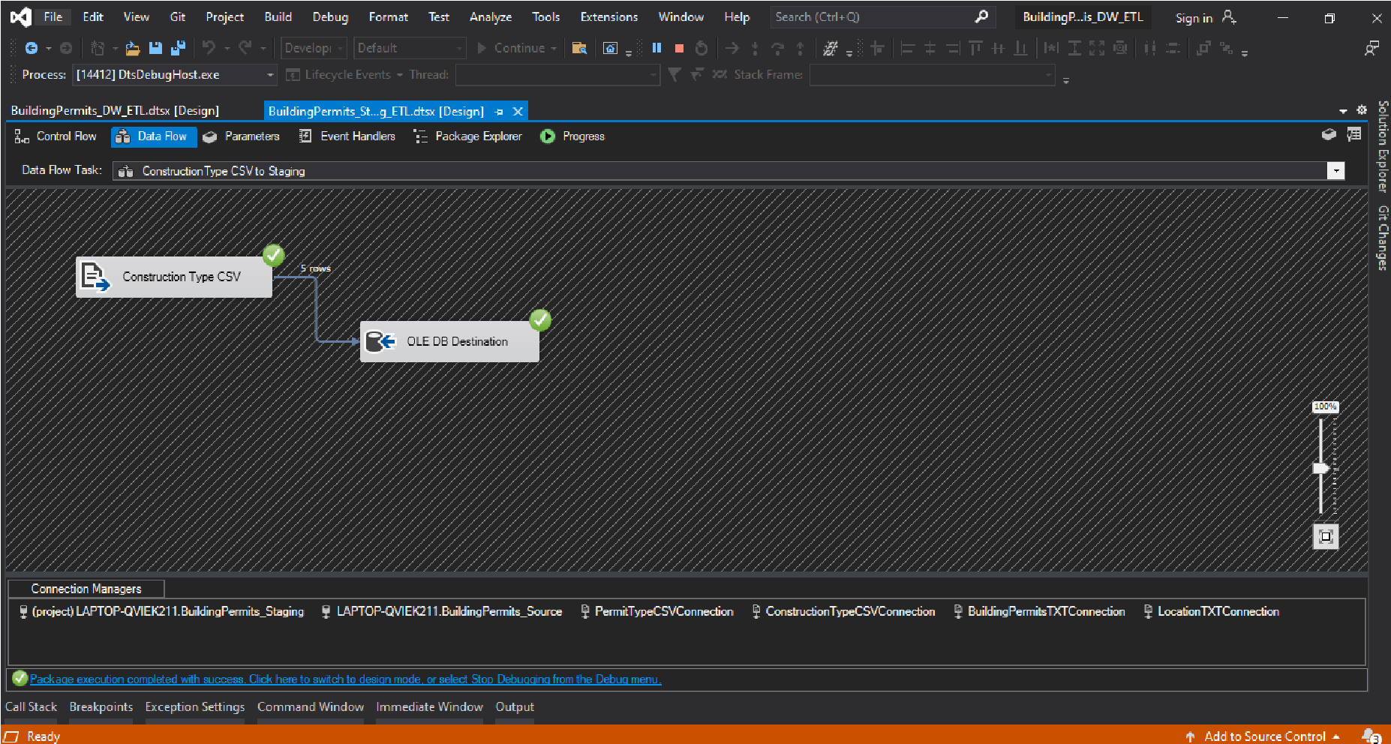

# • PermitType csv to staging

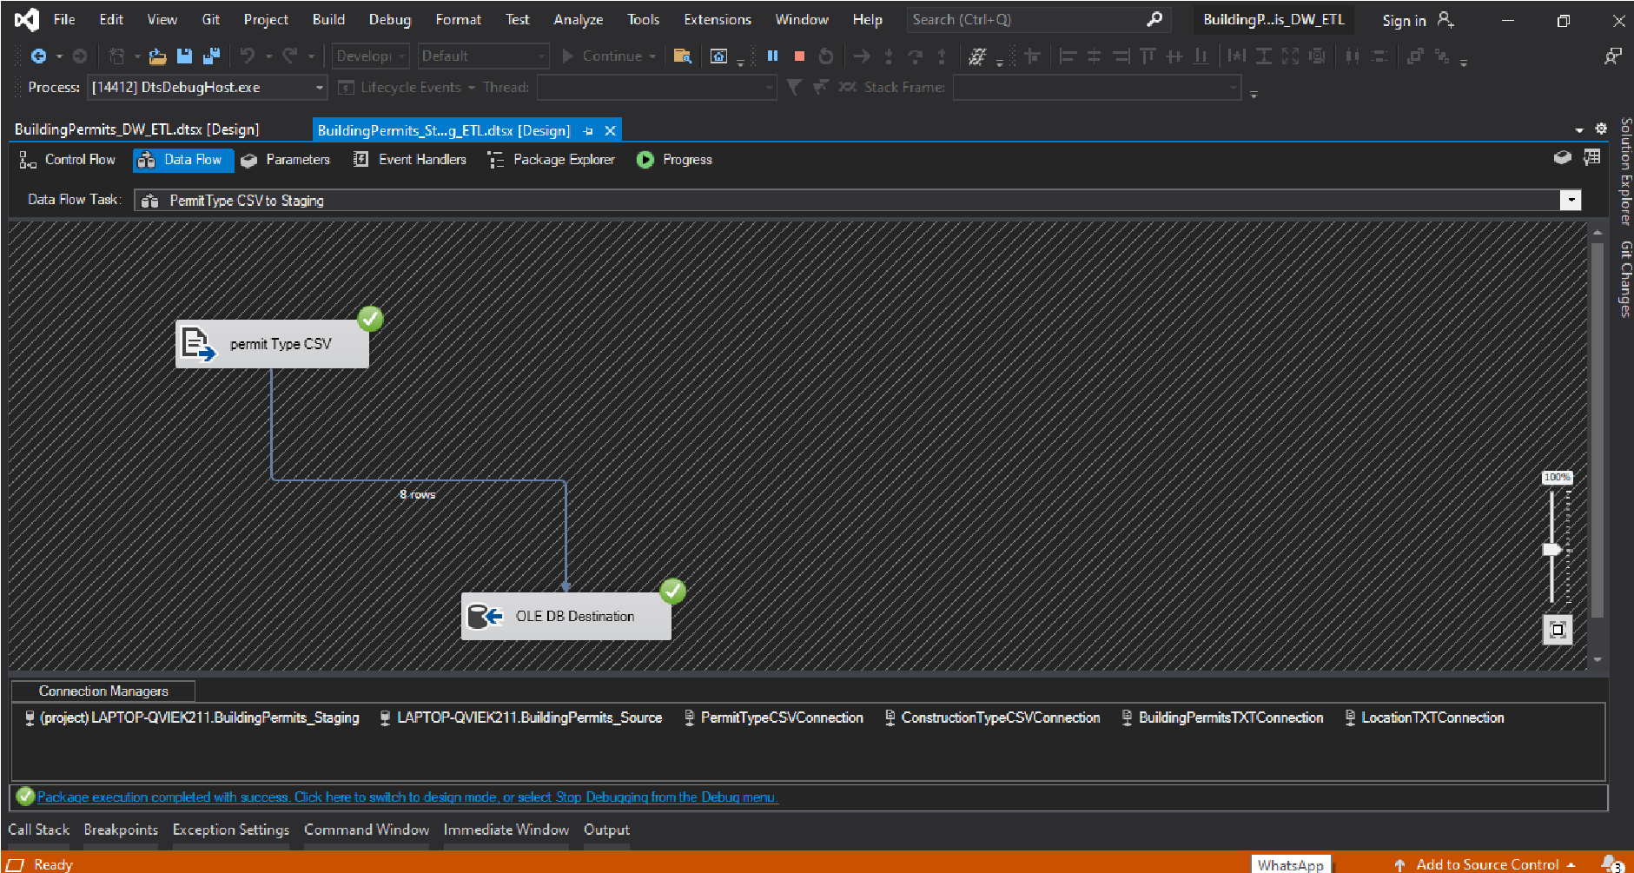

## • BuildingPermits_DWH_ETL.dtsx

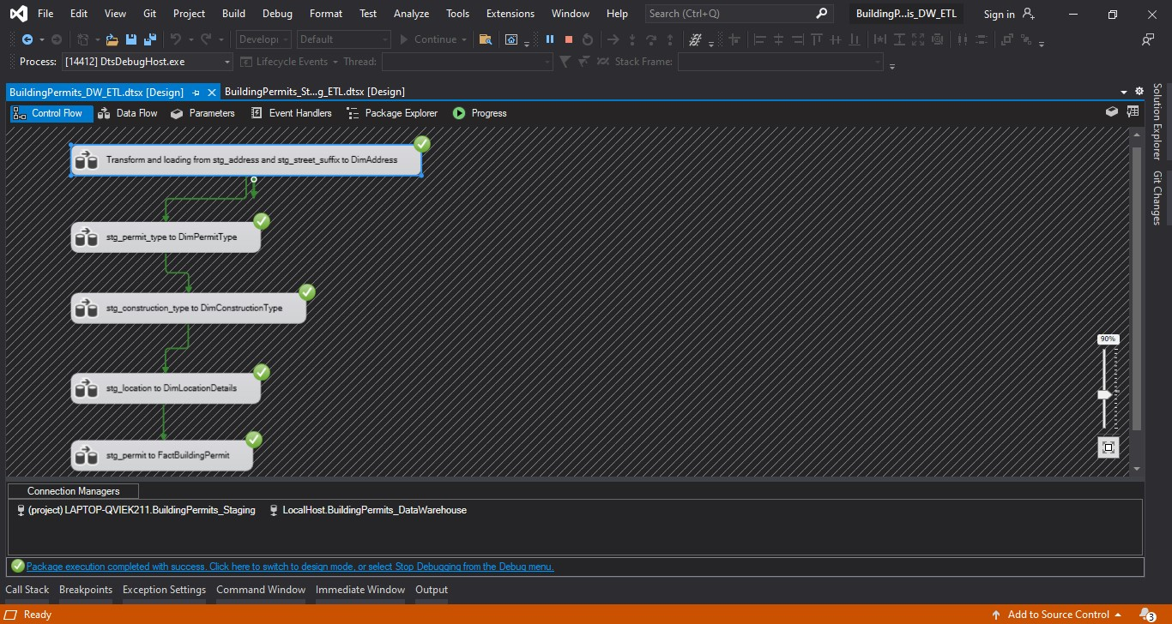

## • Transform and loading from stg_address and stg_street_suffix to Dimaddress

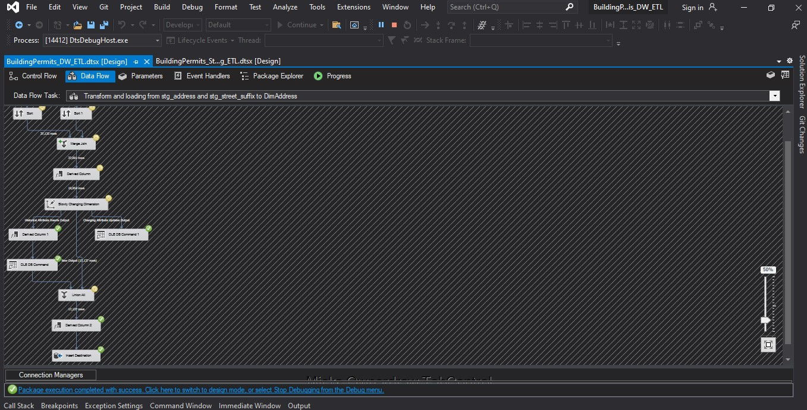

## • Stg_permit_type to DimPermit type

